

Space, Range and Display
Detailed
Solution Architecture

Project BEN Code: | W60336
Author: | John Cowper & Jim JefferyJohn Cowper, Jim Jeffery & Navneet Jain
Date: | 04-Apr-200818-Jan-2008
Version: | 0.0.6
Status: | Draft
Level: | Detailed

Table of Contents
1 Introduction 3
1.1 Management summary 3
1.2 Benefits 3
1.3 Scope 4
1.4 Tesco Enterprise Architecture 5
1.5 Related Document 6
1.6 Project Deployment Versions 7
2 Conceptual Architecture (optional) 10
2.1 Conceptual program level architecture diagram 10
2.2 Rationale for architecture 10
3 Logical Architecture 12
3.1 Logical Application Architecture 12
3.2 Enterprise Information & Integration Services Layer 36
3.3 Logical Information Architecture 39
3.4 Logical Infrastructure Architecture 45
4 Physical Architecture 50
4.1 Physical Application Architecture 50
4.2 Reporting Systems 51
4.3 Physical Information Architecture 52
4.4 Physical Infrastructure Architecture 53
5 Deployment Architecture 54
6 Development Architecture 55
6.1 Development Environments 55
6.2 Development Tools 55
6.3 Development Method 56
6.4 Deployment Considerations 56
7 Operations Architecture 57
7.1 ITOF Stage 1 57
7.2 ITOF Stage 2 58
7.3 Information and Integration 58
8 Assumptions and Issues 59
8.1 Assumptions 59
8.2 Architecture Principles and Exceptions 59
8.3 Risks 60
9 Glossary 61
10 Appendix 64
10.1 Requirements Traceability 64
10.2 Document Control 64

Introduction

Management summary
- Space, Range & Display (SRD) covers:
  - Creating and maintaining space allocations for all new and existing stores
  - Building ranges & planograms for all store formats, sizes and profiles
  - Implementing space, range & planogram changes in store
  - Managing & maintaining all central and store processes, systems & information needed to support these activities
- The key benefits are that:
  - We use our space optimally, ensuring we have the right product categories available to customers
  - We have ranges which are relevant for customers
  - The displays on our fixtures make shopping easy for customers and support the operation
  - Processes are simple for stores and enable stores to implement changes accurately and on time
- Our main dependencies are with:
  - Commercial: to ensure that space, range & display systems are fed with Product, Product hierarchies & Store reference data
  - Supply chain & distribution: to ensure the right ranges get delivered to the right stores on time, and that the ordering systems use the correct capacities
  - Store operations: to ensure stores have all the information they need to carry out all space, range & display activity
  - Property: to ensure all new stores, extensions and refits receive the right space, ranges & planograms
  - MIS: to ensure that group management information solutions include space, range & display reporting, and to ensure that management information is available to space, range & display systems

Benefits
1) Set space allocations
- We optimise the use of our space to ensure we:
  - can carry the right breadth and depth of product categories to satisfy our customers
  - give the right amount of space to each category to support efficient replenishment/stockholding
2) Build ranges and planograms
- We ensure that we are Number 1 for range through:
  - Creating ranges which appeal to all customers
  - Targeting our ranges to match the customer profile of each store
- We build planograms which:
  - Make shopping easy for customers
  - Support efficient replenishment/stockholding
  - Enable good availability and support the customer promise of ‘I can get what I want’
3) Implement space, range & display changes in store
- We ensure ranges and fixtures in store remain relevant for customers through scheduled range reviews
- We ensure ranges and fixtures in store remain fit for the replenishment operation

Space, range & display drives sales and enables efficient replenishment

Scope
See the SRD High Level Solutions Architecture document for details of scope.

It is important to note that Version 1 (See section 1.6 regarding project versions – functional scoping) SRD business processes in the Operating Model (OM) operate within the following constraints:

- Stores must be 100% conformant with centre specified product ranges.
- Business processes do not permit Store Specific Ranging
- All Range changes are driven from scheduled ‘events’
- There is only one floor per store

Briefly this means that, taking each point on turn:

The product ranges sold by the stores are dictated by the Centre/Head Office Ranging Teams and Stores have a responsibility to be completely conformant. This approach is known as “100% Conformance”.

There is no scope for Stores to order or range their own products. Version 1 business processes do not allow Store Specific Ranging. Note that there is scope for them to locally discontinue certain products if this is deemed to be necessary (see Store Range System for details of how this is achieved).

Range changes are planned and scheduled and organised into events that are recorded in the SRD Schedule application. No ad-hoc range changes are permitted.

An SRD Version 1 assumption is that stores will only have one floor per store. Note that this limitation will be removed in future versions.

The SRD Architecture has been driven by a desire to take advantage of the fact that existing UK Space, Range and Merchandising (SRM) project (that supports similar business processes in the UK) represents a significant investment in business analysis, architecture, design and code. This will be capitalised upon by reusing as much as possible where common requirements and integration of systems allow.

Tesco Enterprise Architecture
The Tesco Enterprise Architecture is appended below. The red circles identify the systems within the Space, Range & Display (SRD) domain and additionally where SRD specific extensions to other domain applications or integration layer are required.

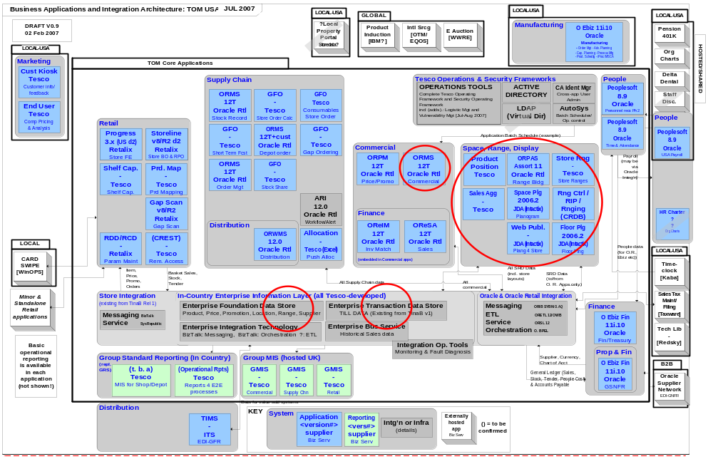
Figure1: Tesco Enterprise Application Architecture

Related Document
Include all documents that are referred to in this document. This should include the Requirements Document, and later, the Business System Design, along with any Exception Compliance Plans

Requirements Documents

Author | Date | Version | Title
Samantha Baptiste | 01/04/2008 | - | Ver 1.5 Requirements ( SRD Docshare)
Hilary Waterhouse | 25/01/2007 | V1.0 | BSD Space Range Display Schedule V1.0
Hilary Waterhouse | 25/01/2007 | V2.0 | Display Group Mgt Requirements Catalogue V2.0
Hilary Waterhouse | 25/01/2007 | V1.1 | Ranging Requirements Catalogue V1.1
Hilary Waterhouse | 25/01/2007 | V1.1 | RIP Requirements Catalogue V1.1
Hilary Waterhouse | 25/01/2007 | V2.0 | SRD Schedule Requirements Catalogue V2.0
Hilary Waterhouse | 25/01/2007 | V1.2 | Store Clustering Requirements Catalogue V1.2
Chris Goldney (JDA) | 15/12/2006 | V2.0 | TescoRequirementsDocument_v2.0
Samantha Baptiste |  | V1.3 | Tesco – Space and Equipment Outbound Interface and Space Reporting v1.3
Samantha Baptiste |  | V2.0 | Tesco – Replenishment Data Interface v2.0
Samantha Baptiste |  | V1.4 | Tesco – RIP Interface – Planogram Creation and Subsequent Range Updates v1.4
Samantha Baptiste |  | V1.2 | Tesco – IKB Object Lifecycles Validation and Status Migration v1.2
Samantha Baptiste |  | V1.3 | Tesco – Stores’ Update v1.3
Samantha Baptiste |  | V1.3 | Tesco – Produce a Map of Products by Store by Planogram v1.3
Samantha Baptiste |  | V1.1 | Tesco – Logical Mod Number v1.1
Samantha Baptiste |  | V1.4 | Tesco – Event Schedule Update v1.4
Jacqueline Thompson |  | V1.4 | Tesco – Product Data Interface and Dimension Change v1.4
Jacqueline Thompson |  | V1.2 | Tesco – Performance Data Import v1.2
Jacqueline Thompson | 26/01/2007 | V0.12 | SRD Product Positioning BRDV0.12
Jacqueline Thompson | 26/01/2007 | V1.0 | SRD_Shelf_Edge_Label_BRDV1.0doc
Jacqueline Thompson | 26/01/2007 | V0.2 | SRD Store Portal BRD0.2
Jun Huang | 21/02/2007 | V3 | Copy of CopyofUSBRBReportingRequirementsdraftv3(SRD)20070201
Mark Pettigrew | 01/02/2007 | V? | Mark Pettigrew-Range Planning Requirement BRD 20070201
Jun Huang | 08/02/2007 | V? | Non-JDA Range Planning Reports Spreadsheet for BRD List 20070207
Jun Huang | 08/02/2007 | V? | Non-JDA Store Merchandising Reports for BRD List 20070207
Jun Huang | 08/02/2007 | V? | Steve_Miller_Store_Merchandising_Requirement_BRD20070207
Sudha Vaidyanathan | 21/03/2007 | V0.6 | Business Requirements Definition For Space Range and Display Sales Aggregation

Business Systems Design Documents

Author | Date | Version | Title
Samantha Baptiste | 20/02/2008 | V0.8 | SRD Finishing ver 1BSD v0.8.doc
Anshu Nautiya | 15/01/2008 | V0.8 | SRD Reconcilliation and Cutover FSD 0.8
Himanshu Nigam | 20/02/2008 | V 1.3.1 | Updating the JDA Architecture with new functionality Store Specific Planogram
Chris Goldney | 15/02/2007 | V1.1 | Tesco – Logical Module Numbers V1 1 (JDA Functional Specification)
Chris Goldney | 02/02/2007 | V1.2 | Tesco – Performance Data Import (JDA Functional Specification)
Chris Goldney | 02/02/2007 | V1.4 | Tesco – Product Data Interface and Dimension Changes v1 4 (JDA Functional Specification)
Chris Goldney | 14/02/2007 | V1.3 | Tesco – Replenishment Data Interface v1 3 (JDA Functional Specification)
Chris Goldney | 14/02/2007 | V1.5 | Tesco – SEL Interface v1 5 (JDA Functional Specification)
Hilary Waterhouse | 01/02/2007 | V0.1 | BSD Ranging v 0.1
Hilary Waterhouse | 01/02/2007 | V0.1 | BSD Space Range Display Controls V0.1
Hilary Waterhouse | 25/01/2007 | V1.0 | BSD Space Range Display Schedule V1.0
Hilary Waterhouse | 01/02/2007 | V1.0 | BSD Store Clustering Phase 1 v1.0
Hilary Waterhouse | 01/02/2007 | V0.3 | BSD Tactical Display Group Management V 0.3
Hilary Waterhouse | 01/02/2007 | V0.2 | RIP BSD V0.2 Updated
Hilary Waterhouse | 01/02/2007 | ? | Tacticalscreenshots
Jacqueline Thompson |  | V1.2 | Store Range BSD1.2
Jacqueline Thompson | 30/01/2007 | V0.5a | BSD for Product Positioning 0 5a
Jacqueline Thompson | 29/01/2007 | V0.4 | BSD for SEL0.4
Sudha Vaidyanathan | 25/05/2007 | V0.6.1 | Business System Design For Space Range and Display – Sales Aggregation

Other Referenced Documents

John Cowper | 20/5/2007 | V0.3 | SRD SAN Storage Volumes v0.3
Sathish Pillai | 31/08/2007 |  | BatchSchedule_US (Both spreadsheet & Visio Diagrams)
Sathish Pillai | 31/08/2007 |  | BatchSchedule_Turkey (Both spreadsheet & Visio Diagrams)

Project Deployment Versions
Because of the sophistication and size of the full SRD solution it has been split into a number of ‘deployment versions’ that embody subsets of the full solutions business processes. Different countries can adopt the version most appropriate to their initial business needs. Note that all countries will be expected to evolve to the ‘full’ solution version over time.
The projects functional scope has been split into 4 versions that can be delivered separately. The projects functionality is both summarised and defined in terms of Business Services (that are described later in the document) and the project versions are defined by listing the Business Services to be implemented in it. Version 0 is a Turkey specific deployment which will be used to support the collection of product capacity information within Stores for the Group Ordering (GO) system and provision of the correct information to StoreLine for the printing of Shelf Edge Labels (SELs). This is a severely cut down instance of the Version 1 deployment containing only Record Product Position.

‘RPP only’ Deployment
This is colloquially known as the ‘RPP Only’ deployment and feeds the GO system. In business process terms:

- Capturing actual space, range & capacity information through product positioning

Space & Display Deployment
This is colloquially known as the ‘Space & Display’ deployment as it supports only Space & Display related business processes and does not drive ordering in GO or any other downstream systems. In business process terms:

- Creating floor plans manually
- Creating generic planograms
- Publishing floor plans/planograms to stores

Full SRD Deployment
This is colloquially known as the ‘Full SRD’ deployment and corresponds to the deployment that supports all of the ‘Version 1’ business requirements – including the ‘Finishing Version 1 requirements’. In business process terms:

- Creating floor plans manually
- Creating generic planograms
- Publishing floor plans/planograms to stores
- Calculating store-specific ranges & store-specific impact of range changes
- Providing range indicators for shelf edge labels
- Capturing actual space, range & capacity information through product positioning
- Creating the actual product map in stores (product in location)
- Managing Display Group hierarchies
- Assigning store clusters to Display Groups
- Creating ranges & basic range modelling
- Managing Store Clusters
- Passing ranges to planogram system & managing workflow
- Reconciling ranges and planograms
- Scheduling events: range changes
- Scheduling events: promotions
- Setting the space-to-range class relationship
- Managing the retail settings & controls
- Reporting (management)
- Reconciling Ranges with Product Management system (ORMS)
- Reconciling Ranges and Capacities with Group Ordering system (GO)

Project Version 2 Deployment
The scope of Version 2 is under discussion with the business at the time of writing but it will minimally include:

- Support for Store Specific Ranging and Planogramming.
- Support for Product Overlay management.
- Replacement of tactical Supported Plans and Equipment Matrix with strategic application.
- Replacement of tactical Commercial Range Security Management with strategic application.
- Replacement of tactical Commercial Range Display Group Management with strategic application.
- Replacement of tactical Commercial Range Retail Setting & Controls with strategic application.

- Enhanced Reporting Capabilities.
- Changes to Systems Integration in order to provide improved performance and better decoupling between systems.

Conceptual Architecture (optional)

Conceptual program level architecture diagram
The following diagram illustrates the program level end state architecture. The property components will not be delivered in SRD Version 1.

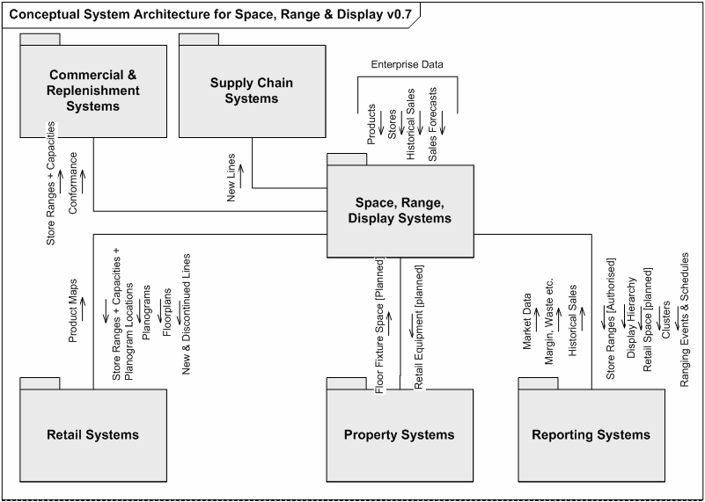
Figure 2 Conceptual Architecture for Operating Model Program

Rationale for architecture
This section describes how the proposed architecture was arrived at.

Architectural Constraints
The existence of a UK Space Range and Merchandising (SRM) solution and the limited timescales within which to develop the Operating Model (OM) Space Range & Display (SRD) solution meant that early in the projects inception an exercise was undertaken to determine the level of reusability that could be achieved from the SRM project in terms of business processes, architecture, design and code. The principle user facing applications of SRM were deemed to be predominantly reusable with most of the new development required to support their deployment into a different integration environment (up and downstream systems).

Conceptual Architecture
As stated above the OM SRD architecture is partly derived from the UK SRM architecture. The architecture consists of a mix of third party packages and applications that were developed in-house. It is a batch-oriented architecture with most data transfers occurring nightly, but some occurring more frequently. At the time of writing the UK SRM system had just gone live with the first Merchandising Hierarchy (end 2006). In this sense, the conceptual architecture is derived from working practice rather than being developed from a set of business requirements. Workshop activities have been undertaken to establish the potential fitness for purpose of the UK solution for other countries and this has demonstrated a relatively high degree of match.

With respect to the Floor Plan and Planogram requirements a number of third party application suites were evaluated. Details of the product comparisons and the ranking process are available. The results of the evaluation were that the JDA vendor offering was deemed to be the most suitable. JDA applications are already in use in the UK model and the familiarity of this tool has helped its adoption in the OM.

There are clearly significant differences between the UK requirements and any other country: language, platform, absence of legacy systems and different integration landscapes. The OM solution also extends the UK solution in that it will also encompass a floor planning component.

The conceptual architecture aims to design a holistic model which is then tailored to the constraints of the target country.

Functional Requirements
The functional requirements have been established as the functionality of the UK system modified where necessary with Change Requests. The requirements are also being documented work stream by stream within Business Requirement Definitions and SIPOCS maps. This document describes the solution in terms of business services. These need to be sufficiently well described to confirm that the business requirements can be satisfied. The requirements documents baseline that this Solution Architecture is created to satisfy are listed in section 1.5.1 and the Business Systems Design documents are listed in section 1.5.2.

Benefits
The benefits of the delivery are that the initial Operating Model candidates (US then Turkey) will have a Customer facing solution that is fully integrated with the other supply chain, marketing and replenishment systems. This will allow the Country and Store management to manage space, construct ranges and display the appropriate products with the correct shelf edge labels.

Risks
There are clearly risks in not having categorical business requirements stipulated but these needs to be balanced against the delivery timelines of the overall Operating Model program. The timeline and scope of the overall program itself is a substantial risk.

Certain elements of the systems inherited from the UK SRM architecture are currently only available in English and have not been written to be internationalised or localised. The “Ranges in Progress” collection of business services that form part of the Commercial Range system are hard coded (screens, messages, error messages) in English and will require effort to recode. The remainder of the business services are built using Microsoft .NET technology using local language files. Local language text will need to be created for each country and checked for presentation.

It is recognised already that the proposed solution will be implemented with as few changes as can be done to the inherited systems. This is to constrain as tightly as possible the delivery time. There are consequences to this though that substantial rework will be required immediately the solution has gone in. There is a danger that this will be further delayed as there are other countries lined up to accept this solution. There is therefore a substantial risk that the remedial work is never completed and that ever more instances are deployed making it linearly more complicated to achieve a point where the application is substantially fit for purpose.

Logical Architecture

Logical Application Architecture
The diagram on the next page represents the logical architecture of the solution. It depicts the systems of the solution and shows the required logical information flows between them. For each of the systems the significant business services (less important ones are not included for clarity but defined in the relevant system description section) are listed within the system bounding box.
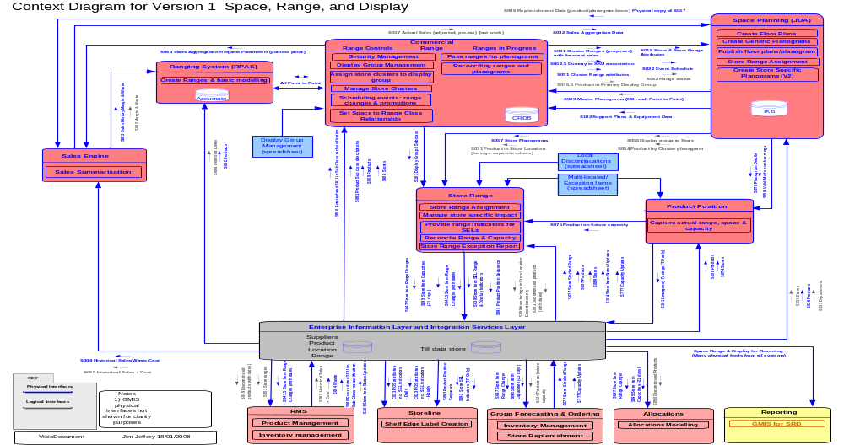Figure 3 – Logical Application Architecture for TOM Space, Range and Display
The SRD systems will consist of:

- Ranging System (RPAS)
- Commercial Range (Range Controls & Ranges In Progress)
- Store Range (Store Specific Range)
- Space Planning (JDA) Intactix Suite - Floor Planning & Planogram creation
- Record Product Position
- Sales Aggregation Engine

The above list consists of systems that support the SRD business processes directly. In addition to these there is a shared integration layer that supports the movement of data between SRD systems and the dissemination of range information to systems external to the SRD domain. In the Logical Application Architecture diagram on the previous page there is a component called “Enterprise Information Layer and Integration Services Layer”. The purpose of this component is to indicate where SRD systems are communicating with systems external to the SRD domain (e.g. ORMS, StoreLine etc) or where SRD systems are reading from or writing to the Integration Data Stores (IDS) in the Integration Layer. Generally the reasons for reading from or writing to the IDS is to decouple the producing and consuming systems not only in data representation but in time i.e. Producers and Consumers do not have to participate simultaneously in the data flow.

Even though there are, what looks like, ‘point to point’ logical data flows on the diagram the participating systems are in fact decoupled by the use of the Integration Layer to manage/perform the data flow. But the Integration Layers participation in the data flow is omitted for diagrammatic clarity. However, for completeness, the SRD system has a requirement for the Integration Layer.

- Integration Layer comprising Integration and Transaction Range Data Stores (IDS and TRDS)

Ranging System (RPAS)

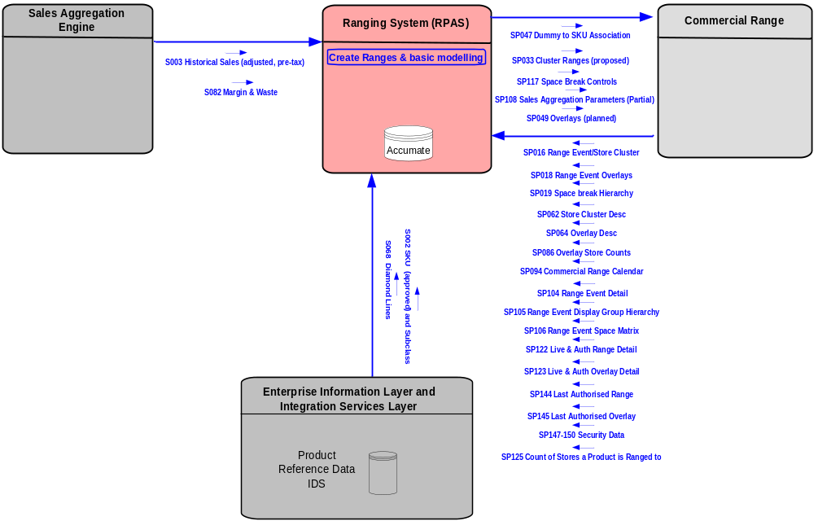
Figure 4 Ranging System Context Diagram

This system is used by Buyers to model and build centrally planned ranges of products to be distributed to stores. It is a Tesco bespoke development built using the Oracle RPAS (Retail Predictive Application Server) platform.

This system is already deployed performing the same function in the UK business and the Operating Model (OM) SRD project will be reusing this component of the UK architecture. In order to reuse this system for the OM the following changes will be performed:

- User interface changed to reflect OM terminology.
- Ensure that it is fully internationalisable and localisable.
- Minor integration changes to enable it to be provided with reference data (e.g. product information) from OM commercial systems.
- Minor internal changes to enable the system to enable it to deal with country variations in Value Added Tax (VAT) regimes. E.g. UK sales feed can provides both ‘VAT inclusive’ and ‘VAT exclusive’ monetary values but this is not the case in the United States for example and thus the system must be able to deal with this in margin calculations.

The exact changes are defined in the System “Business Requirements Document” (BRD) document (See section 1.5.1.

The above context diagram shows all of the Ranging System interfaces with other SRD systems - both the existing UK SRM interfaces (Interface names beginning ‘SP’) that will be reused to/from the Commercial Range system and the new OM logical interfaces. The UK SRM interfaces that will be reused are only for the data flows between the Ranging System and Commercial Range.
The RPAS platform is a proprietary technology incorporating a thick client user interface and an OLAP (Accumate) database for multi-dimensional modelling.

The Ranging System engages in a request/response interaction with the Sales Aggregation Engine (SAE) in order to be provided with Sales History, Margin & Waste Data. The Ranging System does not send its request for Sales History data directly to the SAE but to the Commercial Range system (via interface SP108) that ‘enriches’ the Ranging Systems request with relevant data before it passes the request on to the SAE. The SAE nightly batch response is passed directly back to the Ranging System (via interfaces S003/S082).

The Ranging System is fed Product information from the Integration Layer IDS via interfaces S002/S086. This is a nightly batch feed and is a total refresh of all product information. ORMS is the originating system for product information that feeds the IDS and thus the Ranging System feed will be scheduled to run after the ORMS refresh of the IDS.

As stated at the beginning of this section the purpose of this system is to create/modify centrally proposed product ranges. This activity is scoped by data that is passed to it from the Commercial Range “Range Controls” subsystem. Ranges are built for a specific Display Group associated with a Range Event and sets of Stores known as clusters and for all Range Classes that are associated with this store cluster. This data is setup in the Range Controls subsystem of Commercial Range. The data passed to the Ranging System that represents the context within which ranging is performed and is know as the “Ranging Framework” and consists of the data contained in the batch interface files defined in the context diagram that flow from Commercial Range to the Ranging System. Thus, before the Ranging System can be used there are framework data setup activities in Range Controls that must be performed.

The Ranging Framework batch files are all passed on a daily basis to the Ranging System except for SP094 “Commercial Range Calendar” which is only passed weekly. The Ranging System passes proposed ranges (SP033) and supporting data back to Commercial Range “Ranges In Progress” on a scheduled half hourly basis. This frequency is in order to minimise any delays to the Merchandising User ability to planogram the ranges. This is driven by a schedule rather than event driven due to constraints in the RPAS platform technology.

Once proposed ranges have been created to the satisfaction of the Buyers and have been passed back to the Commercial Range “Ranges in Progress” subsystem then they can be passed into the JDA Intactix Suite to allow Merchandisers to build Planograms. There can be multiple iterations of range building and subsequent placing of them on Planograms before a range is authorised & published to the Store Range system.

Commercial Range (Range Controls & Ranges in Progress)

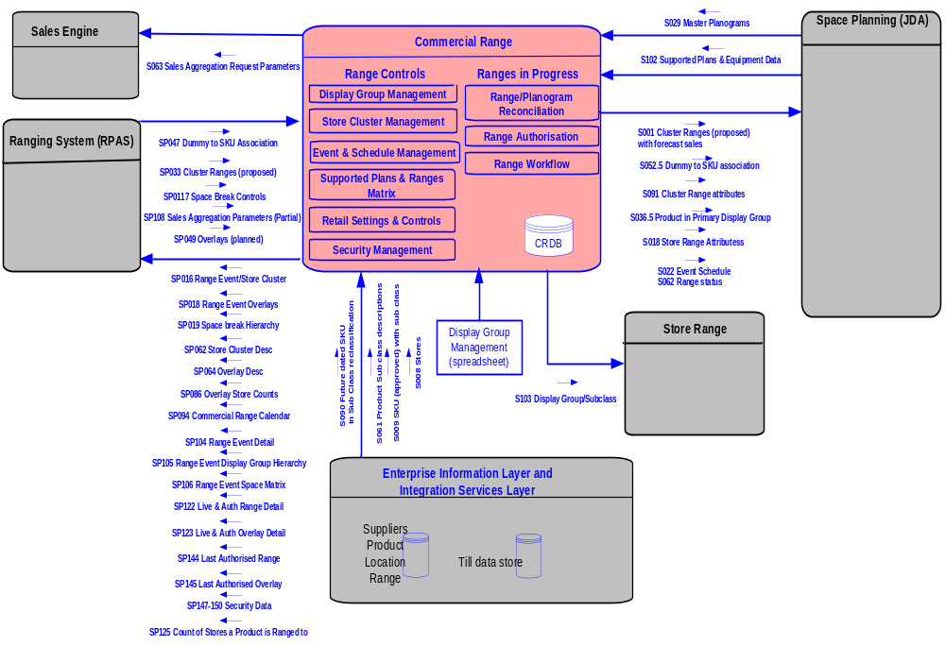 Figure 5 Commercial Range System Context Diagram

This system supports a number of SRD business processes through two subsystems that provide two distinct sets of business services that have a high degree of logical cohesion. The subsystems are called “Range Controls” and “Ranges in Progress”.

Commercial Range is one of the systems to be inherited from the UK architecture and is already deployed performing broadly the same function in the UK business. At the time of writing not all business services within the Range Controls subsystem were fully operational and as a consequence SRD have had to develop tactical solutions that will be used until the strategic ones are available. The details of this are discussed in the following subsections.

Range Controls
The Range Controls subsystem provides a set of applications that together allow users to organise and manage ranging activities. Ranging activities are managed by creating Merchandising Planning ‘Events’ (e.g. Switch the Meat and Poultry Department from winter to summer product range) within which Ranging ‘Events’ are created for each Display Group affected by the change (e.g. each individual Meat & Poultry Display Group) and added to the ranging ‘Schedule’. When a ranging event is created it must be linked to a (single) Display Group. The Display Group, in turn, must be linked to a set of Subclasses that ultimately dictate the set of products that are being ranged. In addition to the Display Group, the ranging Event will be associated with some clustering of stores and these must also be defined. The details of these activities are defined by the relevant business processes, but a list of applications and summary descriptions of each are given below.

- Event & Schedule Management
- Display Group Management (Tactical)
- Store Cluster Management
- Supported Plans & Ranges Matrix (Tactical)
- Retail Settings and Controls
- Security Management

Event & Schedule Management
This application supports the set up and maintenance of centrally planned and scheduled Space, Range and Display Events such as promotional range changes and store opening/refits/extensions. It will also be the control point for sending approved Events to other systems.

It allows user to:
- Add new events including identifying the type of event activity (e.g. Major, Minor, Essential, Promotion).
- Amend or delete existing events already on the Space, Range & Display Schedule system.
- Allows users to control which Display Groups are affected by each event.
- Perform bulk uploads of events from a source spreadsheet.

There are a number of changes that need to be made to the UK version of this application and these are in summary:
- Extend to Manage Promotional events
- Remove UK specific functionality
- Update Interface terminology to be Operating Model compliant

Display Group Management (Tactical)
The Operating Model needs a Display Hierarchy management tool to enable the international business to future-date the links between products and their Display Groups, via the sub class, to coincide with range changes. Ultimately the business will be able to link a product to more than one Display Group, but this is not a Version 1 feature. Display Group Management enables users to add/delete/edit Display Groups and to associate Subclasses with them for a future dated Scheduled Event. This is a tactical solution in SRD Version 1. Users will maintain Display Groups and their associated Subclasses in a spreadsheet. The spreadsheet effectively contains a set of updates to the Display Groups and Subclass relationships. These are loaded into the Commercial Range CRDB database through a manually initiated process that validates the spreadsheet contents. If the spreadsheet contents passes all validation checks then it is loaded into CRDB, otherwise an error report is generated listing validation errors that users must correct before attempting to reload the spreadsheet. Details of this tactical Solution are given in the relevant BSD called “BSD Tactical Display Group Management” (Version defined in section 1.5.2.)

Store Cluster Management
Store Clustering is used by the Space Range & Display Team to define the characteristics of stores and to group these stores into clusters for a future-dated event. The system users can:

- Define the attributes of the stores, e.g. ranging format, ranging country (which may vary from its actual format or geographical country), and can create new attributes, e.g. ethnicity, busyness.
- Define the characteristics by which a Display Group can be ranged, e.g. Upmarket and Mid-market
- In addition, the system can be used for managing Overlays, but this functionality will not be used in SRD Version 1.

Stores are fed into the Commercial Range System from the Integration Layer IDS via interface S008, the IDS having been populated from Oracle Retek Merchandise System (ORMS)
The future-dated Range Events for each Display Group are entered directly into CRDB from the SRD Schedule application (see section 3.1.2.1.1).
Store Clustering is used to create Store Clusters and assign them to the future-dated Range Events for each Display Group.
The ‘ranging framework’ of future-dated Range Event, Display Group, Store Clusters and Supported Range Classes is used by the Ranges in Progress (RIP) subsystem and the Ranging System.
Range Event data (that have been approved) including details of its Store Clusters are fed to Space Planning IKB (via interface S022) on an hourly basis and will appear as attributes of floor plans and planograms (so the correct planogram can be assigned in Floor Planning).

Supported Plans and Ranges Matrix (Tactical)
The Supported Plans & Ranges Matrix is used by the Space Range & Display Team to define the appropriate Space Breaks and Equipment Types that are to be used for ranging and planogramming a Display Group for a scheduled Range Event. Users can:

- Search for and select a Range Event
- Select a Store Cluster assigned to the Range Event
- Assign the Space Breaks for each Store Cluster and specify the number of stores for each Space Break
- Assign Equipment Types for each Space Break within a Store Cluster and specify the number of modules for each Equipment Type.

Range Event details are entered the via the Event & Schedule Management application (see 3.1.2.1.1).
Display Groups & Space Data for each Store is extracted from Space Planning Intactix Knowledge Base (IKB) database into a spreadsheet. This is a tactical aspect of the solution for version 1of SRD. The Space Range & Display Team use the spreadsheet to work out the details required for the Supported Plans & Ranges Matrix application.
The Ranging Controls application requires all the unique Equipment Types and Equipment Type-Display Group relation from IKB .This information is passed from IKB through a file based daily Interface S103 Equipment Type- Display Group
The ‘ranging framework’ plus Equipment Types and Numbers of Mods is passed to IKB for use in Space Planning via interface S001.

Retail Settings and Controls (Tactical)
This application will support the set up and maintenance of controls and settings that are to be applied to the retail products within the Space Range and Display stream. This application is where centrally controlled Space, Range and Display settings will be managed and made visible to other systems. It allows the user to set up and maintain controls for the following:

- Product Position (Version 1)
- Retail Range reporting (Version 2)
- Shelf Edge Label indicators (Version 1)
- Local Ranging (Version 2)
The UK system ‘Retail Range Controls and Settings” is to be used as a basis for the ‘Space, Range & Display Retail settings and controls’ for The Operating Model. However, a few changes need to be made to customise and make it suitable. However for the development of Phase 1 for Space Range and Display controls for Shelf Label Production and for Product Position are the only controls being developed. The solution for phase 1 will be a tactical solution and be spreadsheet based with uploads to the relevant system being required. The Tactical Spreadsheet solution for the UK will be used as a basis for the tactical solution for the Operating Model.

Users will be able to:
- Control the information available on the Shelf Edge Labels (in terms of ranging information) – extraction of indicators for New and Discontinued only –UK tactical spreadsheet exists.
- Control the Product Position application in order to define when the user will be able to update facings Wide, High and Deep. This solution will also include controlling when store users are able to calculate capacities on the hand held device and when they should be fed from the planogram system.

Security Management (Tactical)
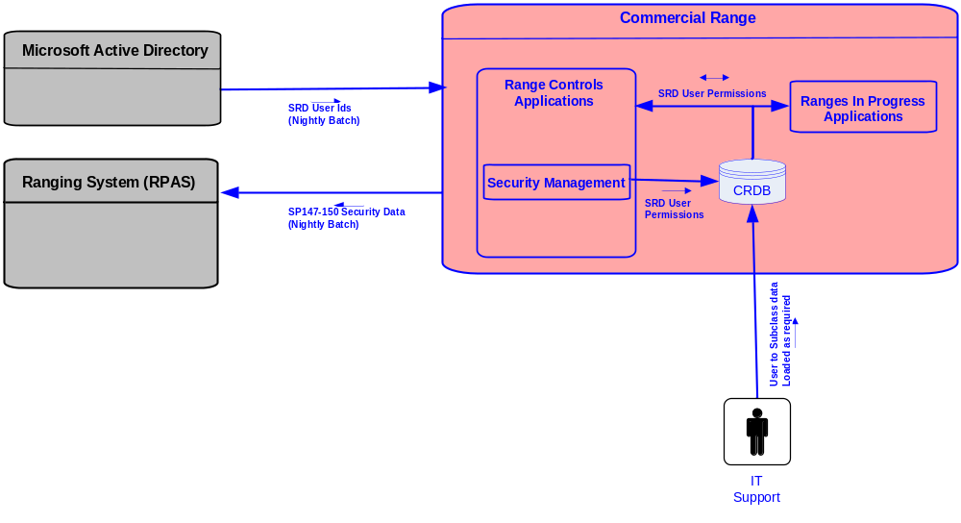
Figure 6 Security Management System Context Diagram

The SRD Security Controls application is required to control access to individual SRD applications based upon a user’s role, the activities they are permitted to perform within an application and the data they are responsible for maintaining within an application.
The system will enable the maintenance of (add, amend, delete) user privileges for SRD applications at the required levels e.g. roles, activities and data and provide a view of the permissions that an individual user has to the SRD applications.

The system users can:
- Assign Roles, Display Groups, Subclasses and Store Clusters to Users in Ranging System
- Assign Roles, Display Groups & Subclasses to Users in RIP System
- Assign Roles to Users in Ranging Controls
- Assign Roles to Users in Display Group Management
- Assign Roles to Users in SRD Schedule
- Assign Roles to Users in Store Clustering

The UK tactical system is to be used as a basis for the Operating Model until the strategic system is ready, but some changes are required to make it suitable, such as changing some of the terminology.

Note: In the UK tactical system Subgroups (Subclasses in the OM) are also assigned to Users in order to further constrain which users can work on what Display Groups. This ensures that multiple users do not accidentally concurrently work on the same Display Group.

A group of SRD users will be set up in Microsoft Active Directory and used to control access to the SRD applications. This group of user ids will be passed to and stored in CRDB on a nightly basis. The SRD security system will then be used to set permissions to SRD applications for these SRD user ids.
Within the security system each user will be given access to an application by setting the relevant permissions for an individual application. Users will be assigned a role (function) for an application, which will control their access to screens and the functions they are permitted to perform.
If it is a requirement of the application that users be restricted to processing subsets of data, for example, subclasses or display groups, these will be assigned for each user for each application.
User permissions will be stored in the Commercial Range CRDB database. The user information is also passed onto the Ranging System on a nightly basis so that the users are consistent across the two systems.

Ranges in Progress (RIP)
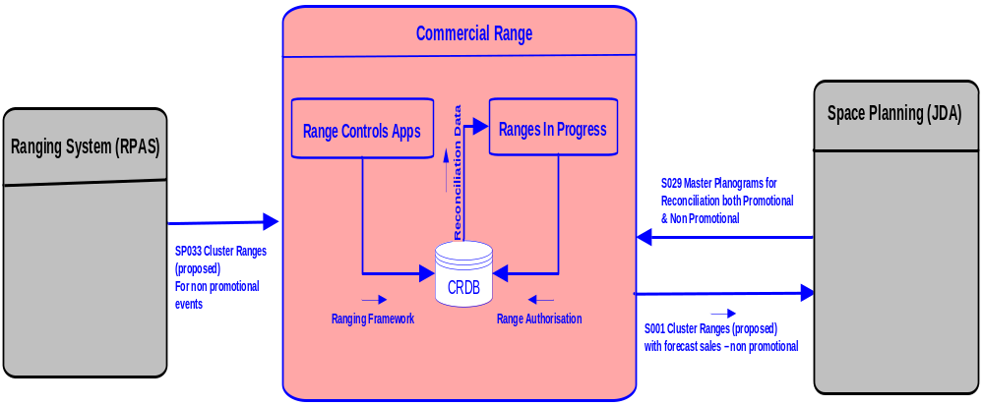
Figure 7 Ranges In Progress System Context Diagram

RIP is an application that has been developed to help reconciliation between the Ranging System & Space Planning systems. It also enables users to authorise ranges upon successful completion of reconciliation. RIP will allow the Display team to view “in progress” range data held in CRDB, reconcile Ranges & Planograms, manage the authorisation of ranges and plans, and control the transmission of authorised ranges to downstream systems.

The ‘ranging framework’ of future-dated Range Event, Display Group, Store Clusters and Supported Range Classes is fed from the Ranging Controls applications into the Commercial Range Database (CRDB) for all display groups, including non-ranged display groups.
Ranges for ranged events are fed from Ranging System to CRDB and onward to Space Planning for planogramming together with space and equipment data.
Ranges for promotional and other non-ranged events are created directly in the Planogram System.
Planogram data and status for all range events is fed from Space Planning to CRDB for reconciliation and authorisation in RIP.
The UK SRM version of this application is to be used as a basis for the Operating Model version, but some changes are required to make it suitable, such as changing some of the terminology. Also, because the Operating Model architecture is different, some of the interfaces will have to be changed.

Assumptions:

- Display Group Management will be used to create separate Display Groups for promotion ends
- Promotional Ranges will NOT be created in the Ranging System
- Promotional ranges must be authorised in RIP
- Non-ranged Display Groups will be used for Promotional Range Events, but there may be other types of Event that also use non-ranged Display Groups
- The RIP system should handle all the ranges in a consistent manner

Sales Aggregation Engine
In order to support Buyers Range building/modelling and Merchandisers Planogramming activities there is a requirement to provide the Ranging System and Space Planning Systems with both current and historical sales data. This provides both sets of users with information regarding product profit margins, costs, waste and sales volumes. In the UK SRM architecture this information is provided by the UK Data Warehouse. The UK Data Warehouse is not a part of the Operating Model architecture and so a new way of providing the required historical sales data is needed. The Sales Aggregation Engine (SAE) System has been designed to satisfy the historical sales data requirements for SRD.

The SAEs source of sales data is ORMS. This provides a daily feed of the previous business days sales volumes, prices, costs and waste aggregated to ‘product in store’ level. The SAE loads this data into the core database tables.

As previously stated in SRD the SAE provides Historical Sales data services to two clients - Ranging System and Space Planning. The engine is fed with a daily feed of ‘yesterdays’ non-aggregated product-in-store level sales, costs, margin and waste data from ORMS. The Engine maintains a rolling 2 year history of this data. For design details of this system please refer to its BSD (ref 1.5.2). The system context is given below:

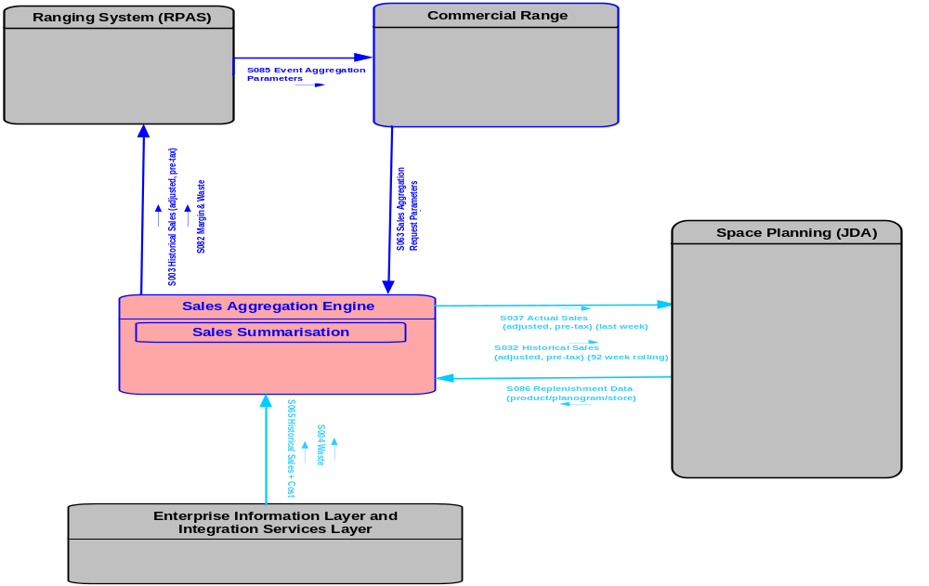
Figure 8 Sales Aggregation Engine Context Diagram

All input and output data flows of the SAE are batch file oriented. The historical sales data requirements of the two clients of SAE are satisfied in different ways as outlined below.

The Ranging System SAE Client Interaction
The Ranging System interaction with SAE follows a simple request/response paradigm but is mildly complicated by the need for the Commercial Range System to enrich the request before it is actually passed to the SAE. On a nightly basis the Ranging System passes to Commercial Range a Request file containing records for all Ranging Events that are currently being built and for each one an indication of whether a fixed or rolling time window of sales history data is required and the length of the time window. This is logical data flow S065 as depicted on the above diagram.

The request file from the Ranging system triggers the Commercial Range system to pass to SAE the enriched request data. The ‘enriched’ request corresponds to logical interface S063 in the above diagram but is physically delivered to SAE as 3 separate data files as the Commercial Range System has been inherited from the UK SRM project. The content and format of each of the 3 physical request files is defined in 3 UK SRM Interface Specifications numbered 113, 109 and 105. In summary, the content of the enriched request data (delivered as 3 physical files) consists of:

- File 113: This file contains a list of the Stores in the Store Clusters relevant to the Events in File 109.
- File 109: The original Event List and time window information from the Ranging System enriched with the Display Group associated with each Event and an indication of whether the event is ‘live’ or not.
- File 105: This file contains a list of the products and their subclasses relevant to the Events in File 109.

The above data is then used by SAE in generating the response data for the Ranging System. This corresponds to logical data flows S003 and S082, but delivered in a single physical file as defined by UK SRD Interface Specification 111.

The Space Planning System SAE Client Interaction
The Space Planning System interaction with SAE differs from the Ranging System in that it is not a simple Request/Response Interaction. Space Planning delivers on a nightly basis a file containing the current Store/Planogram/Product relationships. This is collectively known as ‘Replenishment Data’ and corresponds to logical interface S086 in the above diagram. On a weekly basis the SAE delivers to Space planning two logical data flows S037 and S032. Logical data flow S037 contains actual sales data for the last week aggregated according to the current product/planogram/store relationships. Logical data flow S032 contains a rolling window of historical sales data aggregated from the previous 52 weeks according to the current product/planogram/store relationships.

Space Planning (JDA Intactix Suite - Floor Planning & Planograms)

JDA is an off the shelf package combined with bespoke integration. A previous version of this product that only supports the creation of Planograms is currently in use in the UK. Due to time constraints the approach to the design will be to use whatever components of the architecture and applications of the UK solution work and build strategic or tactical additions to satisfy the Operating Model (OM) requirements. The functionality in the UK is sufficiently close to the OM requirements that the functional requirement for OM is described as the UK model plus or minus specified changes. The working definition of the JDA element of the OM is then a hybrid of UK functionality and requested changes. These changes are detailed below.

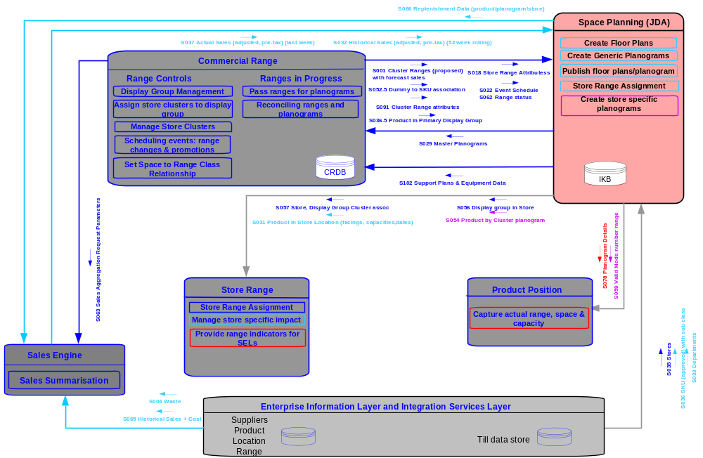
Figure 9 JDA Context Diagram

The entire JDA application suite is shown in the next diagram. The OM requirements in this area are satisfied by the Floor Planning, Space Planning, Web Publishing and Intactix Knowledge Base JDA components.

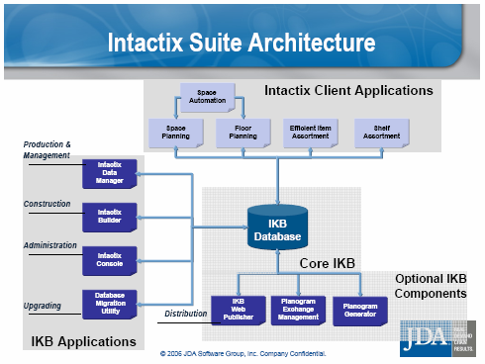

Figure 10 JDA Intactix Suite Architecture

Additional functionality within the Tesco Operating Model specific deployment
Tesco have amended the core JDA functionality with a number of specific enhancements. These are listed below. It is not expected that these changes will prevent JDA regular updates from taking place.

Space and Equipment Extracts
Tesco require the extraction of space and equipment information for reporting purposes and use by downstream systems. The extracts are:

- Scheduled As-Is Space and Equipment
- Ad hoc As-Is Space and Equipment
- Ad hoc Future Space and Equipment (Event based)
- Ad hoc Future Space and Equipment (Date based)

This is delivered through:
- Supported Plans and Space Matrix (spreadsheet)

There is also a custom Space Reporting form design

Replenishment Data (S086)
Tesco require the extraction of store specific product capacity information for the down stream applications.
This extract is enable by S057 Replenishment Data Extract interface.
Store Range and Sales Aggregation Engine are the consumer of this information.

Planogram Creation and Range Updates
The planogramming function is tightly coupled to the ranging function. Data needs to be transferred between these two systems to enable reconciliation to take place.

Interfaces covered are

Inbound:
- S001 Cluster Ranges (Proposed)
- S018 Store Range Attributes
- S022 Event Schedules
- S052.5 Dummy to SKU association
- S062 Range Status
- S091 Cluster Range Attributes

Outbound
- S029 Master Planograms

Object Lifecycles
Additional Object Lifecycle statuses have been added to the Object Lifecycle framework. These are the ‘awaiting sign off’ and ‘signed off statuses’. This necessitates the addition of a ‘sign off’ command in the Space Planning file menu, a Planogram Migration and Status Migration procedure, a ‘sign off’ command in the Floor Planning file menu and a Floorplan Validation and Status Migration Procedure.

Store Data Feed (S035)
Additional data is required to support day to day Store information updates and new store opening processes. A specific interface has been designed to accommodate this. This manages the store data update, the store hierarchy management, the store floorplan update and the floorplan hierarchy update. This does not manage store closures which are closed manually in IKB based on Tesco business rules.

Store Product Map and Interface (S031)
Tesco require a central map of products within a store. This is the position of a product within a planogram within the store and the start mod of the planogram in the store. This is interfaced to Storeline to supplement the shelf edge labelling processes.

Logical Mod Numbering
Tesco require the numbering of mods within the store. The new function will ‘snake’ around the store aisles numbering the mods by incremental sequence number within the fixture groups (departments).

Event Schedule
The Operating Model design dictates that all changes must exist within an event. Status changes occur at pre-determined dates prior to an event happening. This functionality drives the clock which moves changes through their successive statuses. This functionality is tied to the RIP processes. Planograms not created by RIP will be manually approved.

Product Data Updates (S036)
The Operating Model dictates that there is an automatic update of Product data into the system. There is an additional requirement to update new products on request.

Performance Data Updates
To analyse stock fill against inventory targets the Operating Model requires the availability of performance data. This is derived from the Sales Engine as described above. The data required is aggregated (historical) financial performance about Products, Planograms, Floorplans and Stores. Forecast performance data is also required but not handled by this function. This predicts the performance of new products or products new to an event.

This concludes the additional extensions to JDA for the Operating Model.

Supported Business Functions

The following section describes the business functions supported within the various roll out models.

Version 1 includes:
- Create Floorplans
- Create Generic Planograms
- Publish Floorplans/Planograms
- Store Range Assignment

Version 2 includes
- Create store specific planograms

Version 1 Business Functions

Create Generic Planograms
The principal function of the JDA software is to create planograms. Planograms are diagrammatic representations of the modules. JDA uses a library of pictures which approximate the items being merchandised. In this way, an accurate pictorial representation of the mod can be created. In terms of process, a planogram is the result of, typically, a 26 week planning process. All changes occur as a consequence of an event which is managed within the event calendar. Furthermore, no changes will take place which don’t have an event established for them.

Each display group will be re-merchandised to a pre-determined annual calendar. Depending upon the form of merchandising taking place (refit, new store, major- , minor- , out of cycle- range change) a different calendar will be established. Two forms of merchandising occur: ones for range and ones for space. A space event is used in cases where a department moves within the store or a merchandising space break changes size. A ranging event is where the display group is recomposed as part of say a seasonal change.

The placement of the objects on the shelf is a non-scientific mixture of sales performance and aesthetics. The sales performance is analysed through the provision of product, store and planogram information. This striates the products into good, better and best rankings. This is derived by segmenting the range into 3 sections using internal and external pricing information. This would typically be a 60/30/10 split of the range. Suppliers can purchase particular elevations of the product and, to some degree, the relationship of product to product. The buyer and the merchandiser then assemble the planogram from a number of competing drivers. Ultimately, this results in a planogram for a space break.

Previously, the equipment item types will have been provided to the ranging system with a summary of the range breaks. This is a measure of the number of stores with equivalent (under the worthing rules) equipment such that the number of stores with similar space breaks by range class can be calculated. In the UK there is a general rule that a planogram will be created anywhere where there are 5 or more stores with an identical space break/range class structure. This rule will be interpreted for the US and Turkey. The US is likely to have a much more similar makeup due to the restriction of the store formats. It is expected that a ‘one size fits all’ approach will be used in the US. Turkey has a more diversified estate and it is expected that this will require a broader set of planograms.

Once constructed, the planograms are rationalised against the range such that all products within a range are on the planogram and all products within the planogram are on the range. This functionality is described within the range planning function and the ranges in progress application.

Only when this validation has been completed will planograms be released for use.

Create Floorplans
The significant difference between the UK version of Space, Range and Merchandising and the Operating Model Space, Range and Display is the incorporation of Floor Planning within the JDA suite. Floorplans are the representation of the store in respect of the physical layout. Within TOM each store’s specific floor plan is imported from the property system. Floorplans are typically built in a CAD system. Tesco principally uses xxx. All that is required is that the file is imported into the JDA system as a .dwg file.

The .dwg carries a huge amount of information in several layers within the document. This will cover all relevant engineering and construction information which isn’t of any particular use to the SRD process. It does contain the equipment information though as well as physical constraints within the store.

Once imported, the file needs to be calibrated. This is the process of scaling the internal lengths to a suitable size. The floor plans contain the layout and position of all the cabinets/mods that are present within the store. Stores will either be built from new or as an existing property previously owned by a Tesco competitor. Because some stores are acquired as part of a company purchase then the equipment types may be non-standard.

Floor planning can start anywhere in the store but benefits from an organised approach. A typical strategy would be to start mapping the store from the doors and then carrying round the store in some fashion but this isn’t absolutely necessary.

One of the first steps in importing the floorplan is the process of listing the equipment types. At the end of this process, there is a library of fixture types. These objects should be part of the floorplan application database objects but currently aren’t. This means that common library objects can’t be shared between sites. This would be made more efficient by establishing a shared directory of objects.

Areas of the store can be marked as belonging to a department. This carries a 3 character identifier in the Operating Model. There is a JDA UDA which this is preserved in at the store level.

Tesco operate to a standard unit of module. This is a 4ft length of shelving/cabinet/freezer. Each mod is assigned two identifiers: a unique id and a JDA generated id. The JDA identifier is built as a result of the mod snaking algorithm and the departmental code. Currently JDA are having difficulty with the snaking algorithm and this is preventing the accurate allocation of mod numbers.

Mapping the physical layout of the store is a prime requirement

Store Range Assignment
Once the planograms for the space break/range class have been created, it is possible to associate a mod in store with a particular planogram. This is effected by dragging the appropriate planogram onto the appropriate element of the floor plan. The association of the planogram with the floor plan is effectively the store range assignment.

As noted above, this process differs considerably from the UK model. Here, a store can choose the product range that it thinks will benefit the store most.

Publish Floorplans/Planograms
Once the floorplans and planograms have been finalised they are released for publication. Stores access planograms via the JDA web publisher.

Version 2
The significant extension to the Version 1 application is the ability to create store specific planograms. This functionality is currently being constructed by JDA. It is expected that this will not be available before 2008.

Store Specific Planograms
Currently the ability to create Store Specific Planograms (SSPOGS) is available in the UK. This facility is at variance with the Operating Model which dictates 100% conformance. Store Specific planogramming will become a requirement within Version 2 of SRD.

As part of forward planning JDA has been engaged to develop a Planogram Generator tool which is capable of creating the Store Specific Planograms designed to answer the stores specific customer needs. Creation of SSPOGS involves following functional steps.
- Preparation Engine: The outcome of this step is a Target Planogram which will the best fit of the input information provided. In addition to Full Product Planogram and Central Planogram details certain store specific details like space, equipment, range, sales information will be required to get Target Planogram
- Stages and Action: Target Planogram will be tweaked with a series of display rules (e.g. Mod Grouping, Target Shelf Capacity, Blocking, Product Adjacencies etc.) This will provide Final Store Planogram
- Quality Assessment: A set of quality controls are setup in place to ensure the Store Specific Planogram is acceptable to be issued to a store. Some of the quality standards will be level of deviation from the central and full product Planograms, Number of display rules been compromised etc.

The Store Specific Planogram will behave as normal Planogram. This is under assumption that SSPOGS can be integrated with floor planning, space planning and web publisher. Proper architectural details will be included in Version 2 Solution Architecture.

Store Range (Store Specific Range)

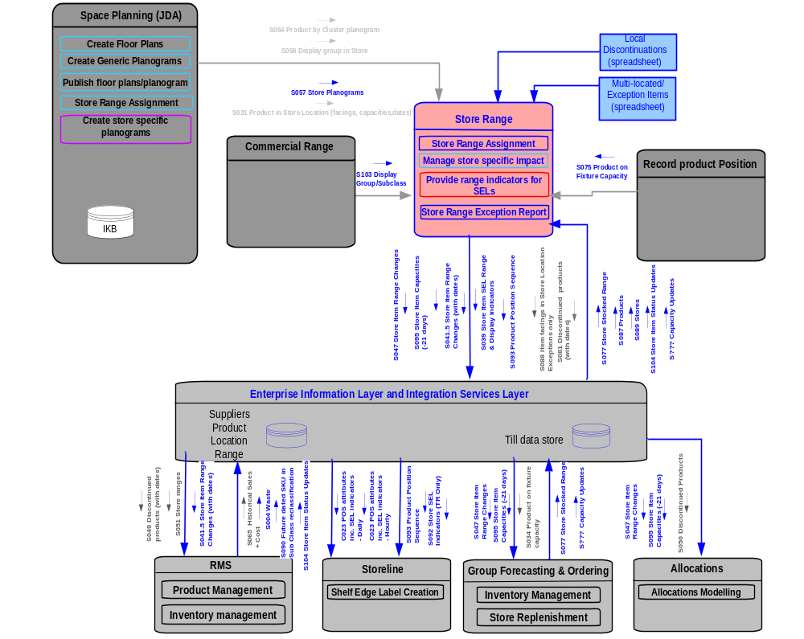
Figure 11 Store Range Context Diagram

The business functions that are supported

- Store Range Assignment
- Manage store specific impact
- Provide display and range indicators for SELs
- Reconcile Range data with ORMS and Range & Capacity data with GO.

The store Range is formally constructed in JDA. This is the master of Range data. JDA not only holds the Store and Product clusters and the associated generic planograms but also holds the Cartesian product of Store by Planogram. This is the definitive Store Range. JDA doesn’t have the processing capacity to manage all these relationships and calculations so, other than master this data, this has been delegated to Store Range.

The other major function of Store Range is as a data distribution engine. Data from Store Range is fed to Storeline, ORMS, GFO and Allocations. The SRD application is the system of record for store location. Products can’t be activated until the base product has been given a location. SRD is the owner of this information. Data is distributed to ORMS via Store Range.

The range/capacity data present in GO and RMS will be reconciled with the Store Range data. Any changes made in RMS and GO to the SRD managed products will be checked by Store Range. A message would be sent back to GO and RMS if there are any discrepancies in the status of product on these systems (SRD, RMS, GO).

Functional Requirements
The functional requirements of Store Range are listed as below:

- Maintain centrally proposed ranges for Stores
- Maintain local (actual) range for a Store
- Identify and communicate changes to a stocked range (for replenishment systems)
- Maintain and communicate planogrammed capacities (for replenishment systems) and support the new store opening process.
- Identify and communicate Range and Display indicators for Shelf Edge Labels
- Pass location sequence to Storeline for Price Integrity purposes
- Maintain and refresh range data for item location status in ORMS
- In Store merchandising conformance reporting
- Provide a tactical solution for the management of high wastage lines

The functional requirements in version 1.5 are
- Centrally proposed range would be reconciled with the actual range
- Actual product capacity in GO would be reconciled with the capacity present in Store Range
- Actual item location status in RMS would be reconciled with the item location status present in Store Range.
- Provide a tactical solution for the cutover of products which are managed by more than one systems.
- Produce daily exception report listing all the exceptions for Ranging Controls.

It isn’t currently intended to run reporting services against Store Range but it is the natural resource for this activity.

Data Model
The Store Range data model is a development of the UK Retail Range Data Base data model. It has been significantly amended to remove superfluous functionality and implement a simpler approach to the Range recording problem. The database is called Store Range but this isn’t an indication of the limit of the functionality. There is no reason why this can’t be used to hold product in physical location (shelf) as opposed to logical location (store). Some tables supporting Storeline location already need this enhanced granularity.

The Store Range data model is:

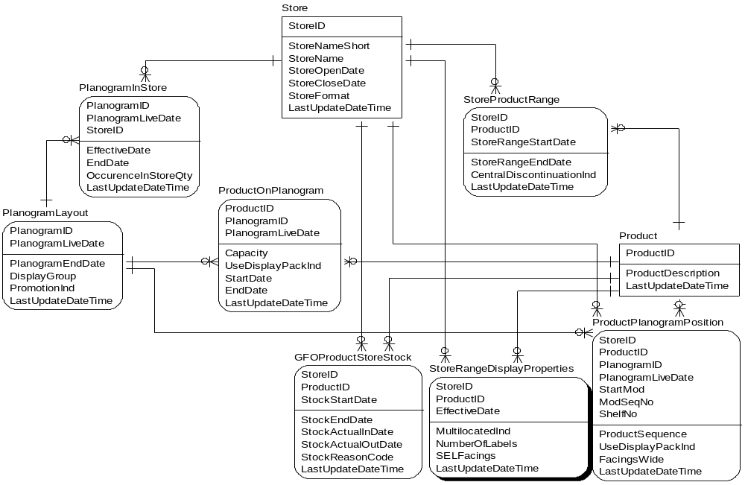

Figure 12 Store Range Data Model

Data is imported principally from the JDA system.

Important Conventions
As a follow on to the UK method of operation, planograms will keep their name through their entire lifecycle. To differentiate one version of a planogram from another requires the use of the live date. Using this combination, we can then hold multiple versions of the planogram.

Record Product Position System
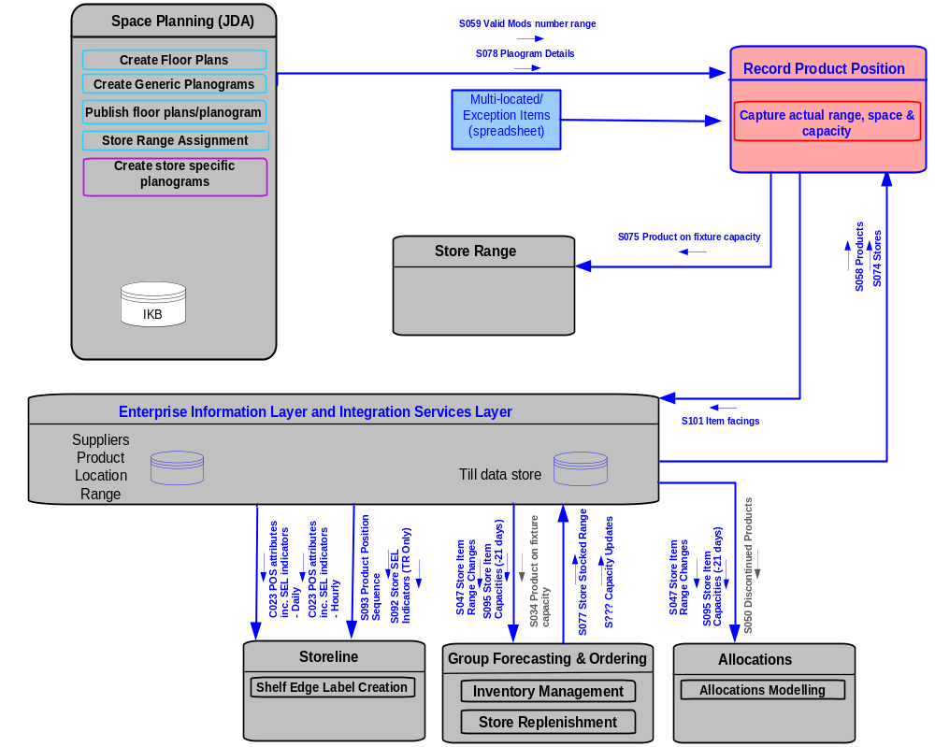

Figure 13 Record Product Position Context Diagram

Business functions supported in both Version 0 and Version 1:

- Capture actual range, space and capacity

The Record Product Position (RPP) Solution Architecture has been constructed independently of this document. Due to constraints on the resource available to the Storeline development team, RPP development was assigned to the SRD development team. However, the ownership of this application is tightly coupled to the Storeline development. As a consequence, the RPP SAD has been constructed as a standalone document. This allows for the re-adoption of RPP by Storeline as and when required. The RPP SAD is referenced in the list of related documents above. The RPP SAD achieved conditional sign off on 01/06/2007. The reader is directed to this document for the detail of the RPP application.

As a brief summary, RPP is the application which records the veracity of the merchandising activity. Under the assumptions of the program, SRD will adhere to a 100% conformance to planogram. RPP is the tool by which the actual merchandising of the store can be recorded. This can subsequently be compared to the planogram.

Data collected consists of either facings (a count of the number of single items along the front of the shelf) or capacity (the cube of facings, height and depth). RPP can operate in two modes as indicated. This relates to the hybrid nature of the application depending upon the maturity of the target organisation. Initially, only facings were to be collected but it was apparent that capacity could also be captured where JDA wasn’t yet implemented which would ordinarily provide the capacity information.

The collection of the data is through a handheld device. This allows the input of either facings of capacity according to the mode in which data is being collected. The mode is determined by assessing whether a planogram exists for the module or not. Prior to SRD being rolled out, no planograms will exist. At or after SRD rollout, planograms will exist for all live mods. An indicator is set on the mod table to indicate whether a planogram is available and this is sent to RPP for use.

Product Positioning is a newly developed application which exists between the handheld devices and the central server. Product Positioning is required to generate the Store Product Map. It will also be used to generate capacities for Stores within Countries where there is no planogramming capability. It will also be used to generate accurate shelf edge labels (SEL) where a discrepancy is identified between the actual product map and the information contained within the planogram.

The Product Positioning application recognises the maturity of the Display Group, Store and Country it is operating in. For Countries with no planogramming capability the functionality is tailored to allow collection of capacity by capturing height, width and depth of the product. This will be used in substitution of the planogram generated capacities. Where planogramming is being rolled out on a Display Group by Display Group basis, the system will know which Planograms will require full capacity collection and which Planograms require only facings collection. Where a store is fully planogrammed (but possibly the country isn’t) the application will only collect facings.

During cutover from existing systems to the use of RPP there might be some scenarios where products are present on both SRD and Legacy systems and planograms. In this case the Product Positioning application will refer to a ‘multi-located’ spread sheet ( for more details please refer SRD Reconciliation and Cut over FSD) to capture capacity. This spreadsheet will list all products which are present in more than one location in a Store (i.e. located on an SRD managed planogram and on a legacy planogam). In this situation the total capacity for all locations in a store will be recorded by the system.

The application will be built as a thin (smart client) browser based application operating from the centre. This will require a continuous TCP/IP connection. The handheld will be able to operate for a period of time out of RF connectivity but this may require some remedial actions when connectivity is re-established.

The handheld devices are a component of the Space, Range and Display solution. Data collected from these devices (Product Positioning) is used (by SRD) for assessing the conformance of the merchandised mods to the centrally proposed ranges. There is no requirement (for SRD) to retain this information at store so the design is a thin client on the handheld device operating against a service on a store based server that messages on a store and forward basis to the central data repository.

The solution is designed to be handheld device independent. The solution allows for a common application communicating through a device specific linking layer. Turkey currently use Intermec 760’s (on Windows Mobile 2002 but upgrading to Windows Mobile 2003). The US is running on Symbol MC70’s (running Windows 2003 Mobile).

The handheld devices are being built to GT&A full strategic standards. By using these standards there is an expectation that the difficulties with application roll out can be avoided. Adoption of the GT&A standards will also allow for any number of applications to be running on the handheld (as there is no permanent application resident and there is no transaction data permanency).

[China and Japan have Intermec 751 for pilot but will move to symbol before rollout.]

A detailed specification of the Product Positioning application is in the detailed solutions architecture.

Space, Range and Display Portal

Note that in the early stages of the project it was assumed there would be a store portal within the operating model application architecture, but this is no longer the case. For this version of the architecture the only access for Stores to SRD related information (Floor plans and Planograms) is via the JDA Web Publisher tool. This may be enhanced when further business requirements are defined.

Enterprise Information & Integration Services Layer
A substantial amount of the data to drive Space, Range and Display will be delivered through the integration layer. In addition some functionality is driven from within the integration layer. Space, Range and Display is driven principally by aggregated sales information. This information cannot be driven from local systems eg Storeline. This data is then provided as a service through the corporate Enterprise services. The following services will be used by Space, Range and Display

Foundation Data Services
This is the reference data available in the service. Space, Range and Display will use the following objects:

- Product
- Product in Location at Price (Range)
- Suppliers
- Location (ie Store)

Product in Location at Price was originally envisaged to be at Store level but this program has requested that this be brought down to shelf level. We have additionally requested multiple locations by product.

Transaction Data Services
This is the transactional data available in the service. Space, Range and Display will use the following objects:

- Sales History (2 year aggregated, Version 1 onwards)
- Operational Sales History (2 week detailed, Version 1 onwards)
- Range Transaction Data Store (Version 1 onwards)

Space, Range and Display require adjusted sales (for stock out, promotion). It is not certain that this can be provided by this service.

Integration Services
This is the integration capability available in the service. Data provided to applications will require certain transformations and enhancements. Space, Range and Display use the following objects:

- Eg consolidation of shelf edge label data from multiple sources
- Conversion of SKU to primary EAN

Scheduling
The SRD architecture can be characterized as a ‘batch-oriented’ architecture. The majority of interfaces are executed during the evening and night following the close of the current business day. There are some interfaces that execute at less/more frequent intervals in order to in order to satisfy certain business requirements.

All scheduling is implemented in the Group scheduling tool Autosys. The detail of the batch schedule will vary by country and SRD version and will be owned and developed by Group Deployment analysts during SRD deployment. Documentation for both USA and Turkey batch schedules may be found in the SRD Docshare Architecture folder – BatchSchedule_US and BatchSchedule_Turkey.

Integration Layer
The integration layer will be an operational service. This will be delivered as a Biztalk instance handling both XML (streamed data) and flat file transport.

Other Components
There are occasional omissions in the delivery of business services. These are identified as ‘yellow boxes’. This occurs where data required by a system from the integration layer is so specific that it will only be used by this system. In these cases a special function will be delivered to satisfy this requirement. The object will belong to the application rather than the integration layer.

Logical Information Architecture
Please refer to diagram below for detail. There is an intention to re-use existing UK interfaces where possible to reduce the time of delivery. Even where the interface is not re-usable any of the supporting data e.g. Technical Systems Design documents, Interface specifications will be reused as much as possible.

Logical Data Flows and System Interdependencies

The Operating Model SRD architecture will have the following form:

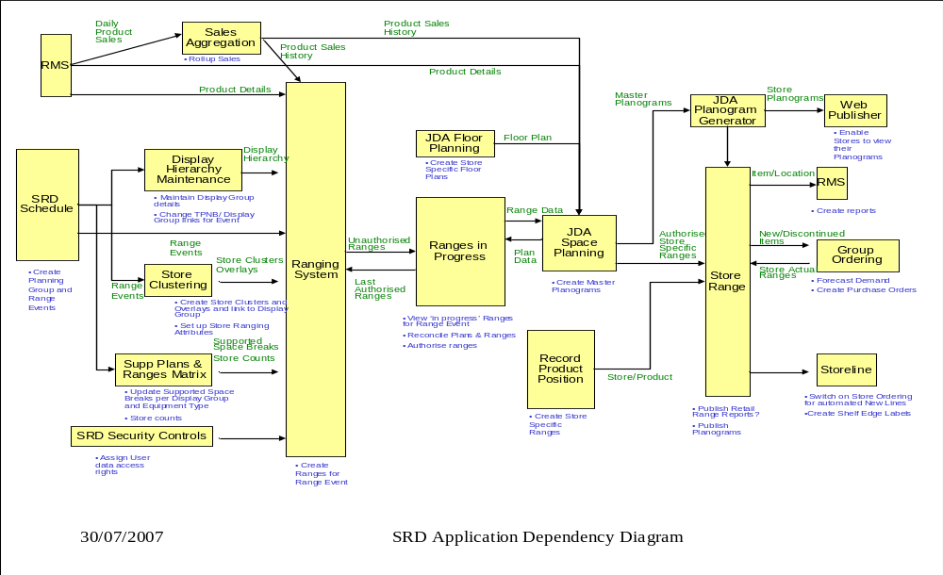
Figure 15 SRD Application Dependency Diagram

For Version 1 the following applications will be deployed on the following databases:

Application | Supporting Database
SRD Schedule | Commercial Range Database
Display Hierarchy Maintenance | Commercial Range Database
Store Clustering | Commercial Range Database
Supported Plans and Ranges Matrix | Commercial Range Database
Ranges in Progress | Commercial Range Database
Ranging System | Accumate/RPAS
Floor Planning | Intactix Knowledge Base
Space Planning | Intactix Knowledge Base
Planogram Generation | Intactix Knowledge Base
Store Range | Store Range Database
Sales Aggregation Engine | Sales Aggregation Engine Database
Product Position | Product Position Database

Data Model
The logical data model for Space, Range and Display is as below. This is a composite of all the business functions.

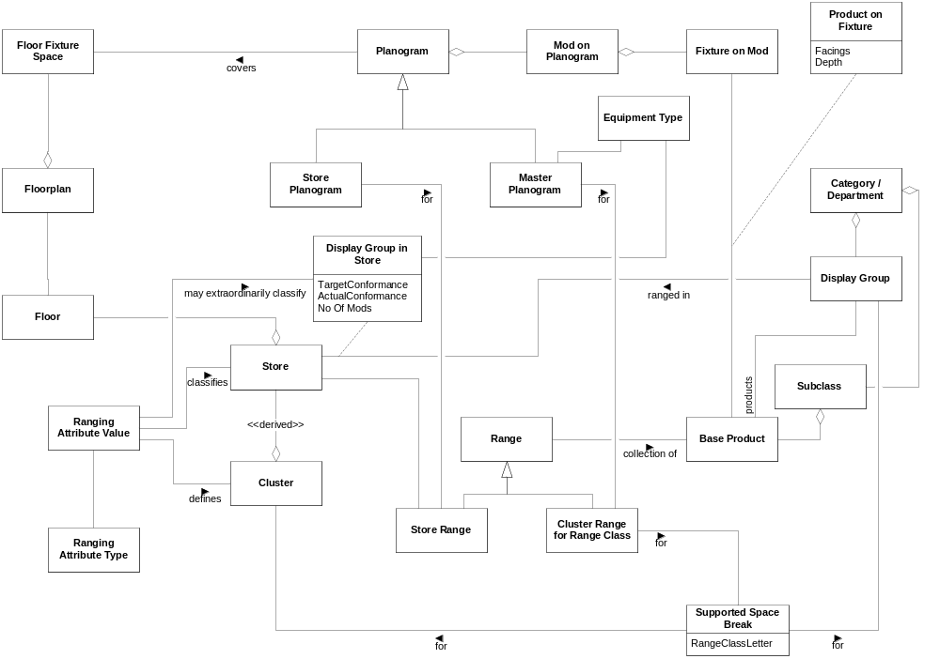 Figure 16 SRD Data Model

Entity Descriptions

Entity | Description
Base Product | The items sold in stores
Subclass | A commercial product grouping hierarchy derived from the ORMS Subclass.
Store | Location where Products are sold
Category / Department | Organisational level used in Merchandising. It represents a set of Display Groups.
Display Group | Organisational level used in Merchandising. It is the level that Ranging activities are performed at. It is a group of Products which are merchandised together, i.e. displayed on the same set of Mods.
Cluster | A set of Stores that share the same Ranging Attributes.
Event | Entry on the Schedule which groups together one or more pieces of work in store which have dependencies between them.
Range | Collection of Products, for a Display Group, suitable for a particular Store Cluster and Range Class.
Range Class | The name given to the supported Space Break for a particular Display Group denoted by a letter A-Z (excluding X). Another way of describing it is as a label for the association of Range with a Value of Mods.
Store Range | The Store specific Range i.e. not a cluster range.
Range Attribute Type | Range Attributes have ‘types’ and ‘values’. Its ‘type’ is a global definition of certain characteristics associated with a Store e.g. It’s Format and Country. Each type will have a set of possible values defined for it. Every store must have one value for each attribute type assigned to it.
Range Attribute Value | The Range Attributes Value is the selected value from the possible set defined by the attributes type. E.g. A Range Attribute type of ‘Country’ with possible values of England, N. Ireland, Scotland & Wales might be set to ‘England’. These values are used to more accurately pinpoint each Stores core range.
Cluster Range for Range Class | A set of Base Products (the Range) designed for a specific Display Group and a specific amount of space (Range Class)
Planogram | Pictorial representation of how Products, in a Range, should be laid out on the mods in the store.
Mod on Planogram | A portion of a Planogram that corresponds to a Fixture
Fixture on Mod | A piece of equipment e.g. ‘Low Level Fixture’ or ‘Standard Ambient’.
Master Planogram | This is a Planogram designed for a Store Cluster rather than an individual Store.
Store Planogram | This is a Planogram designed for a specific Store. Store specific Planograms are a Version 2 feature and not supported in Version 1 of SRD.
Floor Fixture Space | An area on a Floorplan on which a Fixture will be placed.
Floorplan | A plan view diagram of a floor in a Store showing aisles and equipments within them.
Floor | A level of physical space within a Store. A Store may have many floors.
Display Group in Store | An intersection entity for recording Conformance data for a Display Group in a Store.
Product on Fixture | An intersection entity that represents an actual Product on a Fixture. Attributes of Facings and Depth are recorded for this intersection.
Equipment Type | Describes the Mod/Fixture; e.g. FGD is a frozen glass door, LLD a low level dairy, MDD a multi-deck dairy, STD standard etc.
Supported Space Break | Ranges are built for a set of Space Breaks (a number of Mods) deemed suitable for a Display Group / Store Cluster.

Logical Infrastructure Architecture
The high level networking and security architectures are described below. The diagram below displays how the SRD system will fit into the Tesco IT environment. It is split into four groups which are listed below:

- The blue box highlights the users their locations and their access type
- The light yellow box represents the major components of SRD systems and their internal interactions
- The grey box represents the integration layer which facilitates communication between SRD to SRD components as well as SRD to Non-SRD systems
- The dark green box represents the main interfacing systems which will have direct input from one of more components of SRD system

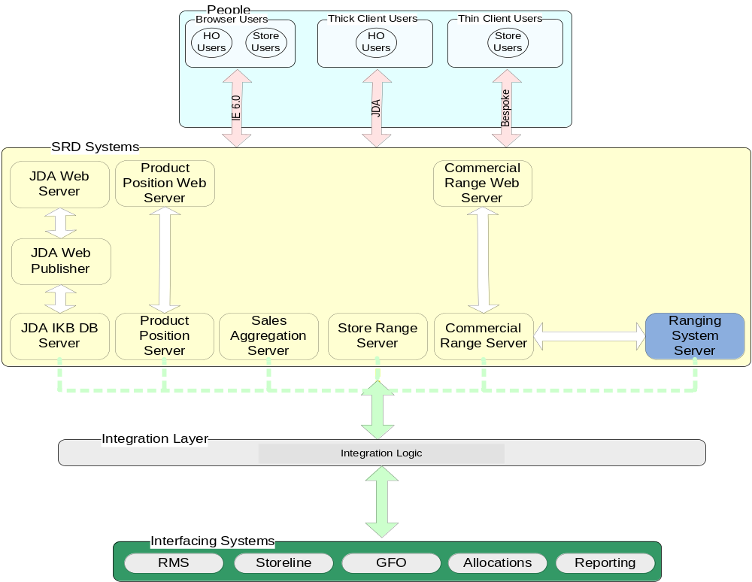

Figure 17 SRD Logical Infrastructure Architecture

SRD System data flows can be grouped into two main flows:

- People to System dataflow
  - User initiate a system request via Internet explorer / Thick client / Thin client
  - The web servers handle the requests except in the case of JDA thick client
  - The web servers requests the required information from database
  - The database provides the required information

- System to System dataflow
  - The SRD systems will generate required output
  - Integration layer / CIFS will pickup the output and provide it to destination SRD / Non – SRD system.

Networking
The Operating Model network architecture is country specific but the SRD network architecture can be represented logically as:

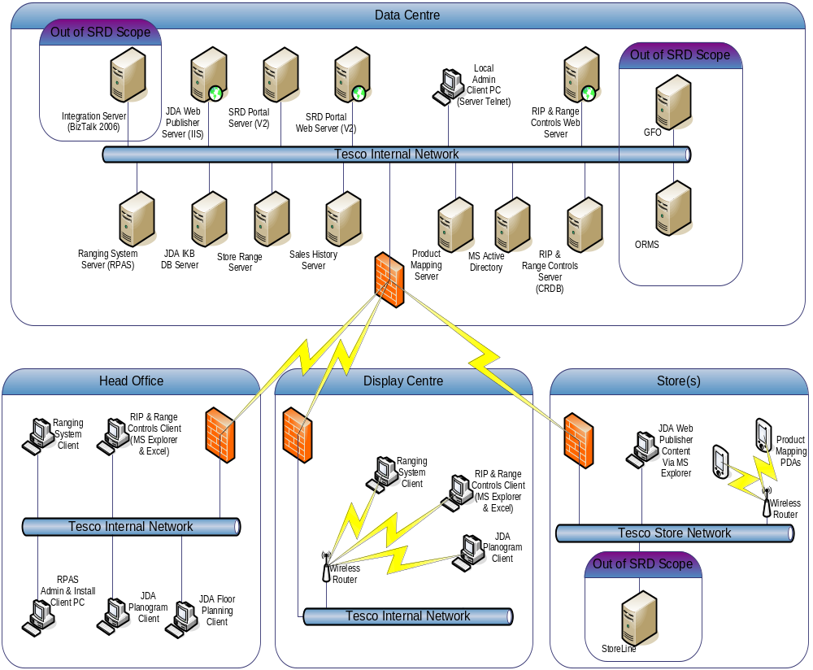

Figure 18 SRD Logical Network Architecture

The above diagram uses logical locations rather than actual to depict the connectivity. An example of the mapping of logical locations to actual ones is given below for the USA network. The above logical locations map to the following country specific locations:

Logical Location | USA Physical Location
Data Centre | Primary Co-Lo Centre
Head Office | USA HQ
Display Centre | Hawthorn Satellite Office
Stores | Stores

The physical locations can be seen on the network architecture for the USA:
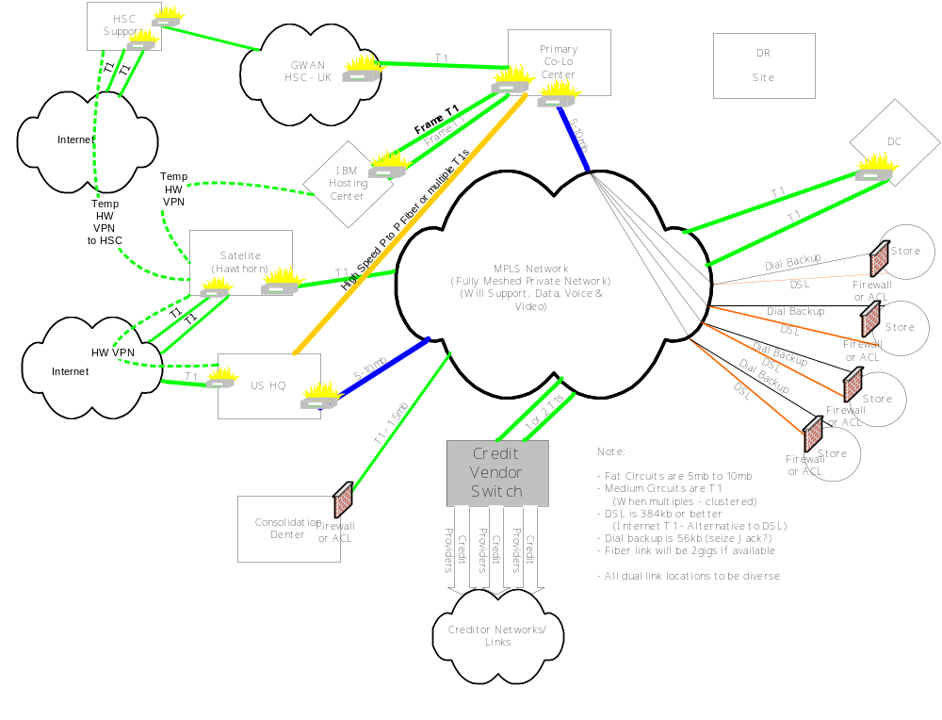 Figure 19 USA OM Network Architecture

Security
Security is addressed at a number of architectural levels and these levels are listed below:

- Network
- Host
- Application
  - Runtime services and components
  - Platform services and components
  - Operating System

Network
The SRD applications are deployed to a number of physical locations as discussed earlier. These locations are all shared with other Tesco applications and thus the SRD network security is addressed by the existing infrastructure (Private Network links, firewalls etc). The SRD applications will be conformant with the security standards applicable within each location. Traffic between locations will be encrypted with technology appropriate to the sensitivity of the data and client/server technology involved in the data flows e.g. use of HTTPS between Store Handheld devices and the Record Product Position Web Servers in the Data Centre.

Host
The SRD Servers in the Data Centre, Head Office and Display Centres will be secured by firewalls within restricted zones. These environments are shared by other Tesco systems and the SRD servers will be conformant with the shared security regimes in place within each of these locations.

Application
To a significant degree Network and Host security considerations are shared by all tesco systems, but Application Security is the most unique. Of the 6 SRD systems 3 are accessed by business users and have user and data access security considerations (Ranging System (RPAS), Commercial Range, Space Planning (JDA Intactix Suite)). The other three systems two (Sales Aggregation Engine and Store Range) only participate in Data Centre Server to Server communication and Record Product Position communicates with Handheld devices in Stores.

Ranging System
Users of the Ranging System are provisioned within a Group in Microsoft Active Directory. On a nightly basis the users are passed to Commercial Range and stored in the CRDB database. Within the Security Application of Commercial Range various permissions are controlled see section 3.1.2.1.6 for details.
The user data and permissions are then passed to the Ranging System on a nightly basis.

No user provisioning or management is done through the RPAS User Management workbook directly. User creation/deletion is all performed within Active Directory.

Commercial Range
Users of Commercial Range are provisioned within a Group in Microsoft Active Directory. On a nightly basis the users are passed to Commercial Range and stored in the CRDB database. Within the Security Application of Commercial Range various permissions are controlled see section 3.1.2.1.6 for details.

No user provisioning is done through the Commercial Range applications directly. User creation/deletion is all performed within Active Directory.

Space Planning
Users of the Space Planning (JDA Intactix Suite) are managed via the Administration Client application (Intactix Console). Users will be able to access the tools using their Windows NT user credentials. For each user an appropriate login must be created in SQL Server Enterprise Manager to support Windows NT Authentication. Roles and Groups are all managed within the IKB database directly though.

Physical Architecture

Physical Application Architecture
This document aims to define the logical core of the Space, Range and Display solution. The physical application architecture is determined on a country by country basis using the constraints and characteristics of that country. The logical application architecture is the basis for the generation of each physical application instance. A broad definition of each platform can be given but this will vary on an instance by instance basis. The entire solution is made from a collection of large components. The following section describes each of these large components and the sub-components that it is comprised of.

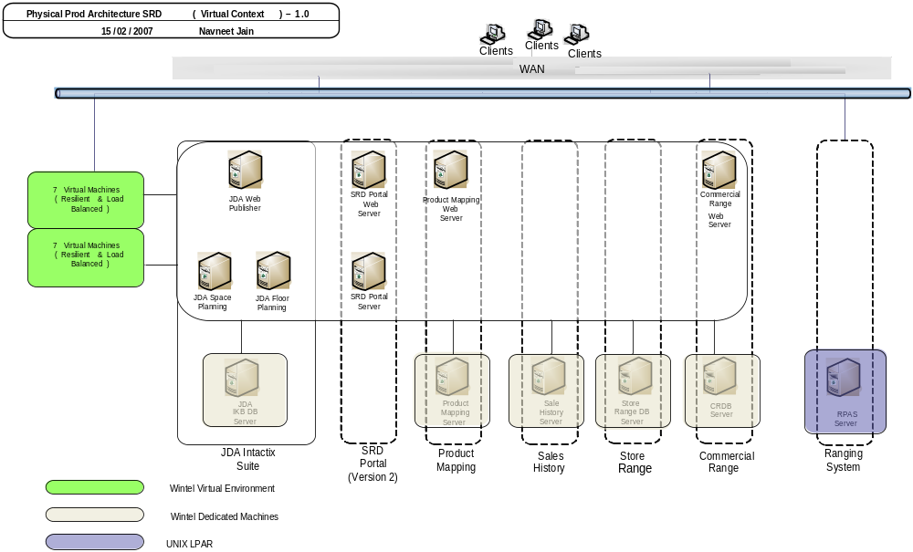
Figure 20 SRD Physical Application Architecture

Infrastructure Details

Ranging System Server - Oracle Retail (RPAS)

Platform Specification: IBM P-Series 2 * IBM p series LPAR (4 CPU, 8 GB RAM)
Operating System certification: Application RPAS 11.2 is certified for AIX 5.3 (RPAS 11.1 is only certified for AIX 5.1)
Storage: 2 * 500GB SAN

Microsoft Windows/Intel Dedicated Servers
All Dell/IBM machines with the following specifications:

JDA IKB Database Server - 2 * (DELL/IBM) (2 Sockets, 2 dual core CPU, 2 GB RAM), Win2K3

Product Positioning Server - 2 * (DELL/IBM) (2 Sockets, 2 dual core CPU, 4 GB RAM), Win2K3

Sales History Server - 2 * (DELL/IBM) (2 Sockets, 2 dual core CPU, 4 GB RAM), Win2K3

Store Range Server - 2 * (DELL/IBM) (2 Sockets, 1 dual core CPU, 4 GB RAM), Win2K3

Commercial Range Database Server - 2 * (DELL/IBM) (2 Sockets, 1 dual core CPU, 4 GB RAM), Win2K3

They will all share SAN DMX/Clarion storage consisting of 2 * 2.9 TB.

Microsoft Windows/Intel Virtual Environment
The SRD infrastructure makes use of Virtualisation technology to provide a resilient and load-balanced environment for 7 machines in the architecture and they are all the Web and Portal Servers as depicted in the architectural diagram. The virtual specification for each of these machines is:

2 * (DELL/IBM) (4 Socket, 2 dual core CPU, 8 GB RAM, 4 NIC-1gb), Win2K3

Storage for the 7 machines consists of 2 * 450GB SAN.

Ranging System User Client

For each Ranging System User the following machine will be required as specified below:
2 * (DELL/IBM) (4 Socket, 2 dual core CPU, 2 GB RAM, 4 NIC-1gb), Win2K3

Windows Thick Client Desktops
Dell/IBM Single Processor – 1 per user

Windows Thin Client Desktops
Dell/IBM Single Processor – 1 per user

Space, Range and Display applications are split between centre and store. The applications comprise the following systems:

Reporting Systems

Operational Reporting
Cross application reporting will be delivered from this service. As yet there are no instances of cross application reporting that cannot be delivered either from the local application or the MIS Reporting service. On this basis, there is no firm requirement for this service to exist.

MIS Reporting
The bulk of the Space, Range and Display reports that have been identified so far that can’t be delivered from local applications appear to be able to be delivered from the MIS Reporting service.

Physical Information Architecture
Not applicable to this document at this stage

Physical Infrastructure Architecture

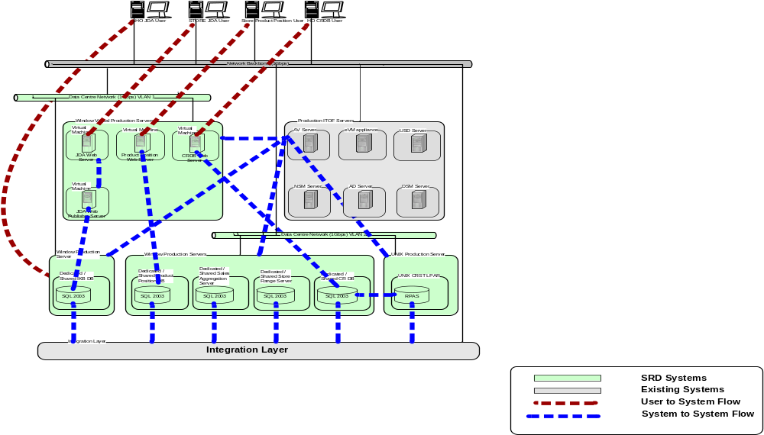
Figure 21 SRD Physical Infrastructure Architecture

Servers:

The physical infrastructure will be based in Data Centre for SRD production system. The following infrastructure will be required:

- Four windows virtual machines running 3 web servers and 1 web publisher, one on each
- One windows dedicated / shared machine running JDA database server. This machine should be in the same VLAN / LAN area where direct access to users is allowed
- Four windows dedicated / shared machines running 4 separate components of SRD system. These machines should be in a secured VLAN / LAN area where only system to system access is allowed
- One UNIX LPAR running RPAS component of SRD system. This machine should be in a secured VLAN / LAN area where only system to system access is allowed

Storage:

The physical infrastructure for storage is SAN based. This SAN would be a tier 2 SAN deployment

Sizing:

Please see the SRD SAN Storage Data requirements document in docshare for details.

Deployment Architecture
Deployment of SRD by countries consists of high level discussions regarding their business strategies and priorities and referencing their architecture road maps in order to determine the most appropriate version of SRD to deploy. Once this has been determined then an in-country management team along with Group support will work a relevant deployment plan, training plan and cutover strategy. This document contains Group recommendations on hardware and software configurations for the full SRD deployment and these are still relevant for the other partial deployments. The actual hardware deployment for any given SRD version will be determined by agreement between in-country IT management and Group deployment Analysts.

Each country deployment will have to deal with the specifics of how to integrate their version of SRD into the local integration and application environments. There may be further development required to create necessary interfaces to integrate with a countries Product Management system (e.g. GOLD) or source of Sales data for example.

The details of exactly what a specific countries architecture looks like should be documented in a country specific Solution Architecture for SRD developed and owned by the country. Group IT may provide assistance and guidance where required.

Development Architecture
The Space, Range and Display TOM Application will be built using standard Tesco Operating Procedures. In this respect all development will be executed in HSC to designs created by the UK Design Team (comprising the Solution Architect and the relevant GT&A Services: Enterprise Architecture, Information Architecture, and Infrastructure Architecture).

The application design will be tailored to individual design within HSC and this will accommodate the local variances. An example of this is the use of RMS version 10 in Turkey and the use of RMS version 12T in the US.

The application will be system tested within HSC but User Application Testing (UAT) will be carried out In-Country. There should be sufficient confidence in the scalability of the application before it is shipped for UAT.

Development Environments
Development
All development within this program is done as a service. The service providers for this program come from 4 agencies: HSC, Tata Consulting Services (TCS), Infosys and SysRepublic. The project will not deal directly with these teams but operate through Integration Services. Where development is performed by other groups on behalf of the project (specifically the IDS and Integration Services teams), the development environment will be provided by the appropriate development group.

Tailoring of the JDA toolset will be performed by JDA to Tesco requirements.

Space, Range and Display will adopt elements of code developed by the UK Space, Range and Merchandising team. Integration of this code into our solution will be performed by HSC.

Test
Three test environments are to be created for this program. This will cover Test, Integration and Patch. Due to the variances between the Turkish and US implementations consideration will need to be given to the different data sources. It is expected that the Integration Layer will moderate most of these differences but this needs to be proven in practice.

Further investigation will be required during design to establish how far through the down stream systems information needs to propagate during testing in order to establish a satisfactory level of confidence.

Staging
UAT will be performed in country.

Development Tools
Where development is performed by other groups on behalf of the project, the development tools will be selected by the appropriate development group.

Development within the SRD project will be .NET based, and thus will be a WOF (Wintel Operating Framework) based development. The tool of choice for this type of development is Microsoft Visual Studio (with C# as the language of choice).

Development Method
Where development is performed by other groups on behalf of the project, the development method will be selected by the appropriate development group.

The elements of development to be handled within the SRD project will follow a waterfall development approach.

Deployment Considerations
The US and Turkey application architectures differ. This may require some tailoring during deployment.

Operations Architecture
This section describes how the SRD applications will be managed and supported operationally.

SRD applications will support the Information Technology Operational Framework (ITOF) Operating Model standards. The ITOF strategy will be implemented in 2 stages.

ITOF Stage 1
This will comprise of:
Application Environment – the monitoring of the physical hardware devices (servers, switches, network) associated with the applications to ensure that they are up, running, and that group infrastructure is accessible. This will also include standard monitoring base thresholds for CPU, disk, virtual, paging, physical memory utilisation and file system monitoring.
Application Processes – the group application processes, services and executables that need to be active to ensure that the applications, and dependant products, are running and accessible ‘online’ to users.
The majority of this monitoring should be achievable by ‘out of the box’ monitoring, but experience to date suggests that in a handful of instances this may require more complex coding which will be delivered in Stage 2.
Benefits
Alerts will be automatically generated to operators when a failure is experienced in the application environment, or the supporting applications processes for appropriate action to be taken. The alert can automatically raise an incident in the Service desk and can be routed accordingly to associated support teams, dependant on the support model.
As an incident is opened in the Service Desk an SLA and priority can be applied to ensure that the incident is by-passed or resolved in a timely fashion to schedule.

Specific SRD ITOF Stage 1 Monitoring
Application Environment
- Availability of JDA Planogram generator, web publisher & web servers
- Availability of JDA IKB DB server
- Availability of SRD Portal Web server
- Availability of Ranging System, previously known as RPAS/CRST/Oracle Range assort
- Availability of Commercial Range server (Range Controls and RIP – CRDB)
- Availability of Store Range System
- Availability of Record Product position server & availability to handhelds
- Availability of Sales Aggregation Engine server
- Availability of load balancers, routers etc
Application Processes
- Intactix Knowledge db application processes and services (underpinning JDA Apps)
- JDA planogram, web publisher and web server application processes and services
- SRD Portal Web server applications
- Ranging System application, previously known as RPAS/CRST/Oracle Range assort
- Store Range System application
- Commercial Range applications (Range Controls and RIP - CRDB)
- Sales Aggregation Engine application
- Record Product Position application services and processes (ensuring handheld availability)

ITOF Stage 2
This will comprise of :
Business process monitoring - this will be more complex monitoring which is required to ensure that the group software is properly supporting the business processes for which it was implemented. Typically, this is not ‘out of the box‘ monitoring and so will need to be customized and coded in line with requirements as the applications are developed. Typically this will involve interrogating application error files and log files.
Any complex infrastructure or application environment monitoring that required development and was not achievable in Stage 1.
Where possible any business process monitoring aspects that are ready and tested in advance of deadlines will be included in Stage 1.
Benefits
This will be customised specific alerting to ensure that key workflows within the applications and dependencies between them are alerting failures and that critical processing and interfaces are taking place to schedule.

Application monitoring will be provided by CA Unicenter. Unicenter Management enables the submission monitoring and management of jobs from a single location and will provide functionality to either alert administrators or automate corrective actions before end users are significantly affected.

Unicenter requires agents to run on the remote servers to be monitored. These remote agents pass back data to the central monitoring application.

Remote Management
The application and infrastructure support will conform to the Group Support Model. Its main provisions are:
- First level support to be provided by an in-country help desk, which is a shared resource across the entire local business
- Second level support to be provided by the in-country support team for that particular application. This team will also liaise with the local business and vendors
- Third level support will be central, currently split between the UK and HSC.

The Tesco guidelines for remote management are mostly based in CA management software thus making use of an enterprise-wide solution.

Information and Integration
As SRD uses the corporate integration layer and the integration data store (IDS), monitoring and support will follow the Group Application Monitoring standards.

Assumptions and Issues

Assumptions

ID | Assumption
1 | Wireless Networks are available in Store

Architecture Principles and Exceptions
This section highlights principles that have shaped the architecture or that cause issues.

Group IT Principles
Principle | Impact | RAG
Enhance the customer shopping experience | A fundamental consideration for Space, Range and Display is the creation of a range of products which is the best available. | G
Increase the capability of our people through better, simpler, cheaper stores | A fundamental principle of the (Tesco) Operating Model is to standardise processes. The very clear benefit from this is the conformity that this brings. By using standard processes, tools and technologies the offerings from the store becomes repeatable thereby allowing better service, simpler procedures and a cheaper model of operation. | G
Create an agile infrastructure to respond to business and systems change | The Space, Range and Display solution allows Tesco to deploy rapidly in a controlled and predictable manner. It isn’t necessarily an agile solution but it allows rapid scaling without losing control | A
Establish common back office systems and processes | A fundamental principle of the (Tesco) Operating Model is to standardise processes. | G

GT&A Application Principles
Principle | Impact | RAG
Future proof design | ?
Buy before build | The Space, Range and Display solution is a composite of in-house built technology and bought in technology. | A
Change the business process before changing the package | ?
One version of the truth | By replicating systems the ability to see ‘across’ the business is significantly enhanced. There is not one version of the truth but it is a substantial enabler to providing it. | G
Make the most of what we have paid for | By adopting the (Tesco) Operating Model the cost of development is spread across every site and geography | G
Think Group act Local | By creating a process model common systems can be created tailored to individual country and store requirements | G
Don’t fix it if it isn’t broken but take it away if possible | Space, Range and Display is a brand new system and therefore can’t be assessed on this point | -
Loosely couple applications and data | Making the data available in the Enterprise-Wide layer will allow us to avoid coupling any other systems to Space, Range and Display. | G
Make data available when needed | The infrastructure is designed to meet demanding service level requirements. | G
Common needs are delivered through common solutions, eg Operational Reporting |  | G
Drive down the cost of IT | The (Tesco) Operating Model will significantly reduce cost | G
Drive consolidation of platforms | The (Tesco) Operating Model will significantly consolidate platforms | G
Retain Intellectual Property in Tesco for competitive advantage | Space, Range and Display has a significant competitive advantage component in the ability to store proposed and actual ranges | G

Figure 22: Adherence to Architectural Principles

Reference | Exception

Risks
ID | Risk

Glossary

Term | Definition
Achieved Worthing Factor | Measure of the Equipment Type capacity, implied by the Supported Merchandise Plan. If 12 mods of this Equipment Type have the same Range Class as 4 mods of the Standard Equipment Type the Achieved Worthing Factor is 4/12 or 0.33
Allocation | Order for new lines, and others, centrally raised for the stores
ASSORT | Former name of UK Commercial Range Support Tool (CRST) – Called “Ranging System” in the Operating Model Space Range Display project.
Capacitising the product | Using facing x height x depth to calculate the number of products that fit into the merchandisable space; formerly known as auto-cubing
Category | A grouping of products in terms of the way they are bought; e.g. Grocery, Bakery, Health & Beauty
Category Review | A proposed change in the way products are grouped into Display Groups including new Products
Cluster Attribute | A term used to describe a characteristic of a Store that allows them to be collected together for ranging purposes. Examples of attributes might be Store Format, Store Region, Affluence.
Cluster | A group of Stores for a Display Group that share common clustering attributes (e.g. Format/Region/Affluence) for ranging; Known as a “Store Range Group” in the UK SRM project.
Commercial | Department (Buyers, Customer Planners, Product Developer) which sources new products, builds ranges
Commercial Range Data Base (CRDB) | The Commercial Range Systems database. It is shared by the Range Controls and Ranges in Progress subsystems.
Commercial Range Support Tool | UK SRM project term for the Ranging System – used to model and define ranges.
Continuous Replenishment | Replenishment which is performed automatically (and usually daily)
Display Group | A group of products which are to merchandised together, i.e. displayed on the same set of mods. Known as a Merchandising Group in the UK SRM project.
Equipment Dimensions | Width, depth and spine height etc.
Equipment Type | Describes the Mod/Fixture; e.g. FGD is a frozen glass door, LLD a low level dairy, MDD a multi-deck dairy, STD standard etc.
Event | Entry on the Schedule which groups together one or more pieces of work in store which have dependencies between them
Event ID | A system generated number to identify each Event on the schedule
Fixture | See Mod
Fixture Map | Program and process used to capture details of each fixture in store (dimensions, equipment type, etc.).
Level Rundown | The objective of ensuring that all of the products have enough stock on the shelf to last until the next scheduled replenishment without holding more stock than necessary at the expense of another product.
Line | Product line, a Product; i.e. new lines are new Products
Merchandise Plan | Pictorial representation of how the Products, in the Range, should be layed out on the mods in the store
Mod | Module, a piece of Equipment in store for stocking products; sometimes called a Fixture
Planned Space Change | Centrally Planned change of a Store’s Space, to take place some time in the future. Usually this change is associated with an Event on the Schedule
Planogram | Diagram showing Products on Equipments.
Pre-ranging | A term used to describe the activity of setting up ranging attributes so that Stores can be clustered.
Product Subclass | Commercial Product Hierarchy maintained and used in Oracle Retail Merchandising System (ORMS)
Range | Collection of Products, for a Display Group, suitable for a particular Store Cluster and Value of Mods
Range Class | Display Group/Store class A-Z (excluding X) but may go 0 -9 as well. A label for the association of Range with a Value of Mods.
Range Density | Measure of the number of different products in a mod, or a Display Group, in the store's actual range
Replenishment | The quantities of Products required by Stores, is calculated as the difference between the stock levels they 'should' have and their current actual stock levels. This calculation is performed, the order is raised then the products are delivered. The 're-filling' of the store is called Replenishment.
Rounding Points | Points for rounding widths of fixtures up or down to the nearest whole mod; e.g. if Rounding Point is 0.75 then 6.8 rounds to 7, while 6.6 rounds to 6
Schedule | The application within the Range Controls subsystem of Commercial Range that manages The Space, Range and Display events.
Shelf Edge Label | Label on a shelf for a product, showing description and price to the customer.
Skim Stock | For a new store, the system orders 1 case of everything to start merchandising the fixtures
Space Audit | The activity in store to check that the right space is recorded for each Display Group
Space Break | Sometimes just a number of mods. Otherwise, an number of mods deemed to be suitable for supporting a particular Range and achieving level run down
Space Policy | Document defining what people may and may not do with space in stores
Standard Equipment Type | For every MGP, one and only one Equipment Type is designated as standard for that MGP; it need not be the STD Equipment Type
Supported Merchandise Plan | Number of mods, of a particular Equipment Type, for a Display Group and Cluster, deemed to be appropriate to support with a Merchandise Plan. Its existence denotes the intention to create a Merchandise Plan
Value of Mods | Amount of space, measured in mods of the Standard Equipment Type for the Display Group.
Worthing Factor | Value of one mod (of a particular Equipment Type) relative to standard Equipment Type for MGP, allowing comparison of different Equipment Types. It compares their ability to accommodate a particular Range and achieve Level Rundown

Appendix

Requirements Traceability
Not provided.

Requirement ID | Element of Architecture

Document Control
Change Record

Authors | Date | Version | Change Reference, description
John Cowper & Jim Jeffery | June 27^{th 2007} | v0.0.4 Draft | First issue
Jim Jeffery | April 4th 2008 | V0.0.6 Draft | Updated to reflect additional requirements for ‘Finishing Version 1.0’

Distribution and Sign-Off

Name | Position | Approver/  Contributor/Other | Sign-Off Date
Mike Yorwerth | Director, Group Technology and Architecture | Approver
Ann Merritt | Lead Architect, Information Services | Approver
Nathan Smith | Lead Architect, Information Services | Approver
Jonathan Summerfield | Lead Architect, Commercial | Approver
Eleanor Koniecko | Enterprise Architect,  Space Range and Display | Approver
Charlie Hope-Lang | Lead Architect, Infrastructure | Approver
Eva Hotmarova | Business Systems Manager, SRD | Approver

